**Table of contents**

**Introduction** 1

**1. Brief history of advertising** 4

**1.1 Pre-printing period** 4

**1.2 Early printing period from the Fifteenth century to 1840** 6

**1.3 Period of expansion, from 1840 to 1900** 9

**1.4 Period of consolidation** 13

**1.5 The World War years** 15

**1.6 Period of business and social integration** 17

**1.7 The Fifties** 18

**1.8 The seventies: after the economic boom** 20

**1.9 The eighties** 21

**1.10 Online Advertising** 24

**2. The Book cover** 27

**2.1 The history of a book cover** 27

**2.1.1 The birth of book covers** 28

**2.1.2 Book covers from sixteenth to eighteenth century** 30

**2.1.3 The nineteenth century and the modern book covers** 32

**2.1.4 Cover books in the 20th Century** 42

**2.1.5 Contemporary world and book covers** 58

**2.2 Conclusion** 60

**3. Developments and graphic transformations of publishing houses** 62

**3.1 Einaudi Editore** 63

**3.1.1 The Einaudi history**  63

**3.1.2 The Einaudi graphic design** 65

**3.2 Adelphi** 76

**3.2.1 The Adelphi history** 76

**3.2.2 The Adelphi graphic design** 79

**3.3 Conclusions on the analysis of the graphic design of Einaudi and Adelphi** 88

**3.4 Different graphic choices between non-fiction and narrative** 89

**3.4.1 History of the publishing house “il Mulino”** 89

**3.4.2 Graphic evolution of the series "Saggi" Il Mulino** 90

**3.4.3 Covers comparison** 94

**4. CssLibrary** 96

**4.1 Birth of the CSS Library** 96

**4.1.1 Files in the Library** 97

**4.2 Use of the CSS Library** 104

**4.2.1 Reproduction of existing covers** 106

**4.2.2 Creation of covers following the style of Adelphi, Einaudi and il Mulino** 110

**4.2.3 Creation of a new cover for "I promessi sposi"** 114

**4.3 General evaluation of the library: pros and cons** 117

**Conclusion** 123

# **Introduction**

The look of the book is crucial for the sale, most of them are initially judged by the cover. However, there are not numerous studies that deal with book covers from a graphic point of view, which instead has a more central position than is often believed.

For this reason, my thesis aims to analyse and bring to light a fascinating but not yet adequately studied theme, at least in some aspects: the birth, function, evolution and design of the cover in contemporary publishing.

In particolare ho voluto sperimentare la realizzazione di una CSS library che potesse facilitare la creazione delle cover book, in particolare della prima di copertina. L’intento è quello di fornire un sistema facile e semplice da utilizzare che permetta, attraverso la modifica unicamente di tre file, di cui uno HTML contente il testo che si vuole visualizzare sulla copertina, un file CSS che il designer non ha necessità di modificare, dedicato alle informazioni relative alla dimensione di questa e la sua visualizzazione su device differenti come tablet, smartphone ereader e computer ed infine il file CSS dedicato al designer che può sfruttare per personalizzare la copertina. Nel capitolo dedicato alla libreria, oltre ad una spiegazione più dettagliata, verranno mostrati degli esempi pratici dell’utilizzo della libreria per testare la sua funzionalità cercando di soddisfare necessità differenti tra cui riprodurre copertine di edizioni già esistenti, crearne di nuove, basandomi sullo stile di note case editrici ed infine creare copertine inedite. Ho voluto testarne il funzionamento e capire se potesse essere uno strumento che una casa editrice o un autore indipendente sfruttare.

L’idea è nata riflettendo sugli strumenti e le modalità utilizzate per la realizzazione delle copertine. Attualmente ci sono vari modi attraverso cui poter creare book cover tra cui ad esempio affidarsi ad un grafico, servizi di tools online o software che facilitano la creazione. Attraverso questi strumenti in alcuni casi si rischia di creare una copertina generica che raggruppa caratteristiche già viste in altri libri pubblicati e di avere costi elevati per la creazione. Facendo alcune ricerche non ho trovato metodi che si servissero di CSS library e del linguaggio HTML che invece sta diventando sempre più presente nel campo dell’editoria, in particolare, quella digitale. Quindi la possibilità di sfruttare questo tipo di linguaggio permette anche di rendere i file, nel nostro caso le copertine più flessibili e a andrà a vantaggio di un vasto pubblico.

Ritengo sia importante, quando si parla del mondo dell’editoria focalizzarsi sull’importanza delle copertine e la sua realizzazione

perché we live in an era of visuality. It is therefore not enough to study a literary text alone: even the image on the book cover is implicit in the way the text is perceived by the potential reader.

Today the book should be considered as an integral project, which is why its image, the business card for potential clients, plays a key role: the cover. Its task is to attract the reader's eye, thus playing fundamental role in the purchase of the product.

The book, through the cover, currently self-publish: communicates a message to a recipient able to decode it. As in any advertising communication, however, the message is not neutral but adheres to precise persuasive strategies that have the purpose of buying the book (D'Ambrosio 2008, 139).

The cover is seen as packaging, a "poster for the book", which can help build a brand for both the book and the author. Publishers use the covers to draw attention to the authors' names and to give each of them an identifiable brand identity. Among publishers, there is also a competition that leads to visual experimentation to stand out from the crowd, to create a distinctive trait, to sell, but especially to create a unique publishing project.

Lavori simili al mio e come attualmente si creano le copertine

Suddivisione della tesi e le sue parti più sviscerato perché li ho trattati- ancora facalizzaizone su parte tecnologica

Given the role that covers have today, in attracting readers and promoting their sale, and therefore the presence of existing analogies with the world of advertising, in the development of the project, I considered important to start by showing a general overview of the history of advertising and the main graphic trends that have characterized it over the centuries from the first posters in ancient Greece to the one on the internet, to underline the main phases and those characteristics that can be found in the graphics of the covers, such as references to Futurist art, film posters in 1950 or the use of bright colours and typographic experiments typical of 1970s advertisements.

After dedicating to the analysis of the evolution of advertising, I focused on the covers of the books that, which has led them to be a tool through which to protect texts and make them visible and attractive.

A book cover is always part of a particular historical moment, and for this reason, it is an extremely interesting historical source: it requires a certain iconographic taste, economic practices, even specific social relations. What seems sure by now is that it is impossible to think of criticism as purely textual based exclusively on the text, disconnected from reflection on the processes of production and consumption, on editorial mediation and on the material forms of conveying the book. The meaning of a text is the object of negotiation between author, publisher and reader, and the paratext, first of all, the external one, appears as the place where this real semiotic battle takes place, for this reason, it is fundamental to analyse this aspect of the book too (D’Ambrosio 2008, 148-149).

It also emerged from the reflections made that book covers are not designed to be narrative representations of the book's content, as they were in the past. On the contrary, the modern design of the covers has been redesigned to be a more abstract representation of the reading experience. These covers do not intentionally contain information about the characters or plot but are instead focused on the recreation of a feeling about the content.

Another aspect found, which I mentioned previously, is that book covers are similar to product packaging in terms of their importance in affecting purchasing decisions. The books, despite being highly experiential in nature, still share several elements with conventional consumer products. The book publishing industry is aware of the importance of book covers in sales, and therefore takes many steps to research and produce images in line with ideal standards. For some years now, the design of book covers has been a fundamental part of a company's marketing strategy for the sale of books.

In other words, the information on the cover plays an important role in the efficiency of the marketing strategy.

Undoubtedly, there are multi-layered communication strategies behind it. First of all, there is a definition of the target group to whom the purchase should be made. Even before approaching the issue of editorial affiliation, it has been observed how important it is to recognise the effectiveness of gender identity, which is transversal and often positive. Genres and, above all, narrative subgenres have somehow developed their own immediately recognisable para-textual syntax (D'Ambrosio 2008, 141).

During the study, not only paper covers will be considered, but also digital covers that should make people curious enough to click on the thumbnail of the cover and learn more about the book.

After a first part dedicated to the backstage of the publishing world: from the general analysis of the history of the covers and the curiosity to examine the editorial graphics. Follows a reflection on the evolution and the graphic design of some Italian publishing realities that have made graphics and corporate image distinctive features: Adelphi and Einaudi. An interesting analysis that will allow finding in concrete terms those characteristics encountered in the previous chapters on advertising and the history of covers. Moreover, to have an even more complete picture of the peculiarities of the covers, I decided to compare those of these publishing houses, famous above all for narrative texts, with covers instead of non-fiction text, in particular by the publishing house Il Mulino.

The analysis of the graphic evolution of these publishing houses represents a further term of comparison useful for achieving a more global vision of the complex world of editorial design.

The comparison between different realities of the Italian book industry allows underlining the importance that in the last few years has reached the publishing graphic design industry assuming the first-order role and leading the publishing houses to start real overall graphic designs or specific series that have contributed to their expansion.

Consequently, to get a better approach to the world of publishing graphics, reflecting on the need to have different formats of the same cover, I decided to find a way to make it easier by using: CSS and HTML. For this reason, I created a CSS library that allows to quickly and immediately create book covers in different formats suitable for eReaders, smartphones, tablets and traditional covers. My intention, in addition to accelerating the production process, has been to allow to create completely different covers using the same files: the HTML file, related to the information to be displayed on the cover, a CSS file, intended for properties that must remain the same regardless of the style of the cover and, the only file that can be modified by the designer: a CSS style sheet related to the characteristics of specific covers.

# **1. Brief history of advertising**

Before proceeding with the analysis of the book covers, the main theme of this project, considering the importance of the characteristics of advertising and its design for editorial graphics, here follows a reflection on its history.

The advertising does not have an actual date of birth. It is an extremely articulated form of communication that has changed many times throughout history. The most intense phase of its evolution is closely related to the development of modern industrial culture. It was only with the second industrial revolution of the nineteenth century that it entered into a phase of maturity that gave it its present appearance (Terenzi 2012, 26).

Advertisements can be considered a mirror of life, a sort of fossil history from which the future chronicler might fully and graphically rewrite the history of our time (Pope 2003, 1).

Advertising has responded to changing business demands, media technologies, and cultural contexts.

## **1.1 Pre-printing period**

When exactly did advertising begin?

It is not simple to identify the precise moment when the advertisement was born because it gradually took shape. In the ancient civilizations, the type of communication closest to advertising, as we intend it today, was represented by the signs used by merchants to attract customers.

The first advertising graphic in history was an Egyptian papyrus inviting the citizens of Thebes to help the weaver Hapu locate a fugitive slave. The seller at the end of the advertisement had added this slogan: "The weaver Hapu's shop, where the most beautiful fabrics of all Thebes are weaved, according to everyone's taste" (see Figure 1).



**Figure 1: The Egyptian papyrus of Thebes.**

**Source:**<https://www.agpubblicita.net/storia-della-grafica-pubblicitaria-antica-dal-secondo-millennio-avanti-cristo/#:~:text=La%20prima%20grafica%20pubblicitaria%20della%20storia%20fu%20un%20papiro%20egizio,ricompensa%20una%20moneta%20d'oro.>

In ancient Greece, but also in Rome or Pompeii, the first advertising messages were announced by voice by the public auctioneers (praecones) who performed in the Greek Agora and the Roman Forums. A medium of the time was the Greek axons or Roman albums: wooden surface and masonry covered with white paint on which public and private advertisements were written.

In 131 B.C. in ancient Rome was commonly used small sheets of paper (libellus) to hang, which later became the Acta Diurna, the ancestors of our newspapers. The Acta Diurna was a daily gazette that informed citizens of political and social events, they were engraved on metal or stone and posted in areas with pedestrian traffic.

Many merchants, in ancient Rome, placed on their shop's signs in relief, painted or mosaic, which had inscriptions for the few pedestrians able to read or symbolic images easily understood by the rest of the population, almost completely without education. The need to promote was born with the passage from offering products on the street to selling them in a closed room, such as the shop. This transition made it necessary to use a particularly eye-catching external signal to draw the attention of those passing by (see Figure 2).

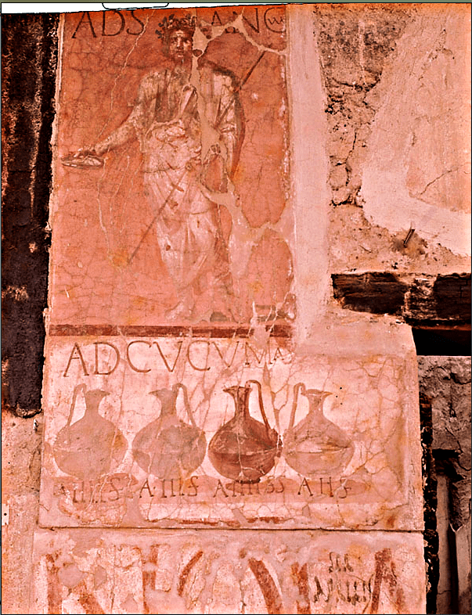

***Figure 2: Pompeii, a sign at the entrance to a shop. It depicts four pitchers of different colours, with the drinks that were sold here and an indication of the price of the wine. Above instead, the figure of Semo Sancus, a local divinity. The panel at the bottom is the announcement for a show.***

***Source:*** <https://www.agpubblicita.net/storia-della-grafica-pubblicitaria-antica-dal-secondo-millennio-avanti-cristo/#:~:text=La%20prima%20grafica%20pubblicitaria%20della%20storia%20fu%20un%20papiro%20egizio,ricompensa%20una%20moneta%20d'oro.>

In the Middle Ages, commercial images were supported by those of religious and military spheres. These forms of religious and military communication can also be considered the origin of advertising. But it was especially during the Renaissance, with the great development of the city and international commercial traffic, that the need to promote the qualities of a product became apparent. At the time, this need was satisfied by street salesmen, who described the goods aloud to their customers in markets and trade exhibitions (Codeluppi 2001, 13).

## **1.2 Early printing period from the Fifteenth century to 1840**

Most histories of advertising start in the mid-nineteenth century. Therefore, there is a general agreement that advertising emerged with the Industrial Revolution (Codeluppi 2001, 13).

In order to blaze the names and virtues of their products into the memories of consumers, the company branded their goods and began to advertise them (Tungate 2007, 11).

The invention of mobile printing in the fifteenth century made it possible to create the first posters for the streets of European cities. Gutenberg's printing press (1438) introduced the era of mass communication, because it was possible to produce printed materials in series, whereas, before the printing press, books and other printed materials required individual production (Montenegro 2017).

It is important to remember, however, that until the nineteenth-century posters were mainly made up of official or religious notices. One of the exceptions was the poster made in 1477 by the English printer Caxton to promote the thermal cures. It represents the first poster of a commercial nature (Codeluppi 2001, 14) (see Figure 3).

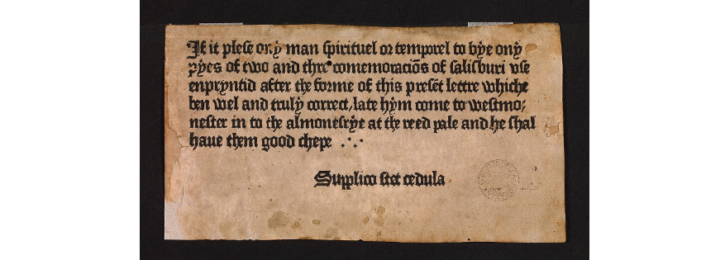

**Figure 3: Salisbury Spa Treatment manifesto- Advertisement for William Caxton (Oxford, Bodleian Library, Arch. G e.37, datable to 1476-77).**

**Source:**<https://digital.bodleian.ox.ac.uk/inquire/Discover/Search/#/?p=c+0,t+,rsrs+0,rsps+10,fa+,so+ox%3Asort%5Easc,scids+,pid+8f9942c0-8d77-4e7c-adf1-fd69fcf0f92f,vi+527c9ad7-e7b6-4727-a2b4-5afbc27f0539>

In the seventeenth century, thanks to the evolution of printing techniques, the "gazettes" were introduced in the main European countries. They were generally published once a week and they are relevant because provided a wide space to réclame, a French term that denotes what we can consider the first proper form of advertising. It was still empty of illustrations and was based on a text similar to newspaper articles, usually promoting business and sales, but also books and pharmaceutical substances (Codeluppi 2013, 14). It seems that the first forms of réclame appeared in 1625 in England on the "Mercurius Britannicus".

Subsequent magazines containing exclusively advertisements such as the "Public Adviser" were distributed (1657) (see Figure 4). Also in Italy between the end of the seventeenth century and the beginning of the eighteenth century, the first forms of newspapers were introduced to the public (Codeluppi 2013, 14). The oldest réclame on the Italian peninsula was published in 1691 in Venice on the "Protogiornale veneto perpetuo".

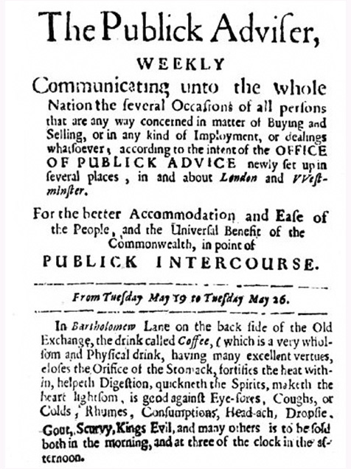

**Figure 4: the first advertisement for coffee in London, published in 1657 on “the publick adviser” Source:** <https://uslogo.net/uslogo-companies/print-advertising-dead/>

It is mainly in England that there has been an intense development of réclame in several newspapers (see Figure 5). It is not a coincidence that it happened in this country because it was here that the process of industrialization began in the eighteenth century. And it was in 1786 that the figure of the advertising agent was born (Codeluppi 2013, 15); it developed as a result of the intuition that advertising users would benefit considerably from the possibility of buying from a single source the space available in the many newspapers and gazettes spread around the territory.



**Figure 5: example of an English newspaper presenting announcements about «patent medicines»**

For two centuries, advertising remained linked to newspapers. They provided the ideal vehicle for this new phenomenon, advertisements, in part because new technologies were also making newspapers cheaper, more widely available, and more frequently printed (Montenegro 2017).

In England, advertising speeded up its development from 1833, thanks to the reduction of the tax on it and benefited from the economic expansion resulting from the second industrial revolution. In Italy, in those years, there was a considerable expansion of the economy. The newspapers made the success of the advertising possible.

## **1.3 Period of expansion, from 1840 to 1900**

Thanks to the invention of lithography, created by Aloys Senefelder in 1796, wall posters with black and white images and printed characters had started to cover the walls of the most important cities. Newspapers were read by an audience that was still too limited as far as the communication required by companies was concerned. Despite this, for posters, on a type of graphic construction was adopted primarily influenced by the model of the book and literary writing: a text written with a compact, undifferentiated, and linear typography, with few titles. In other words, it was an advertisement essentially created to be read (Codeluppi 2001, 16) (see Figure 6).

Despite the predominance of this type of model, in the nineteenth century in advertising, the form of the slogan began to be adopted: a synthetic phrase capable of surprising and capturing attention (see Figure 7). The slogan, however, obtained a real recognition only in the twentieth century, when the predominant role was assumed by the image and not by words.

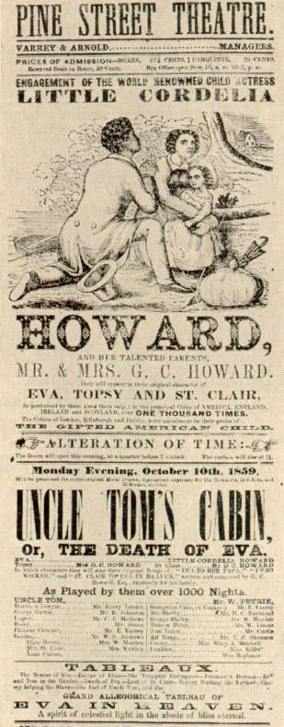

**Figure 6: Poster for Aiken's Dramatization of Uncle Tom's Cabin (1859). Source:** <http://people.virginia.edu/~sfr/enam312/entindx.html>

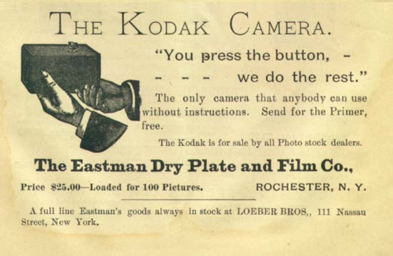

**Figure 7: Second half of the nineteenth century. The name "Kodak" was born and the KODAK camera was placed on the market, with the slogan, "You press the button - we do the rest." Source:** <http://thenewpictorialism.blogspot.com/2011/>

In the nineteenth century, editors were the first to use illustrated posters, who commissioned them from illustrators, to advertise the lithographic tables created by the artists themselves. Quickly the posters were also used by theatres, cabarets, and equestrian circuses, which, having to attract large crowds, offered spectacular images of their attractions. But it was only in the second half of the nineteenth century that the possibilities provided by chromolithography, a colour printing technique born in 1836, were fully exploited. The advertising poster, thanks to the use of colour, improved its expressive effectiveness (Codeluppi 2001, 16).

The advertising message thus became, in the following decades, less immediate but more articulated and complete. In the evolution of the modern advertising poster, the contribution of Henri de Toulouse-Lautrec was also fundamental; he created Divan Japonais (1892), Jane Avril (1893) and Babylonne d'Allemagne (1894) (see Figure 8).

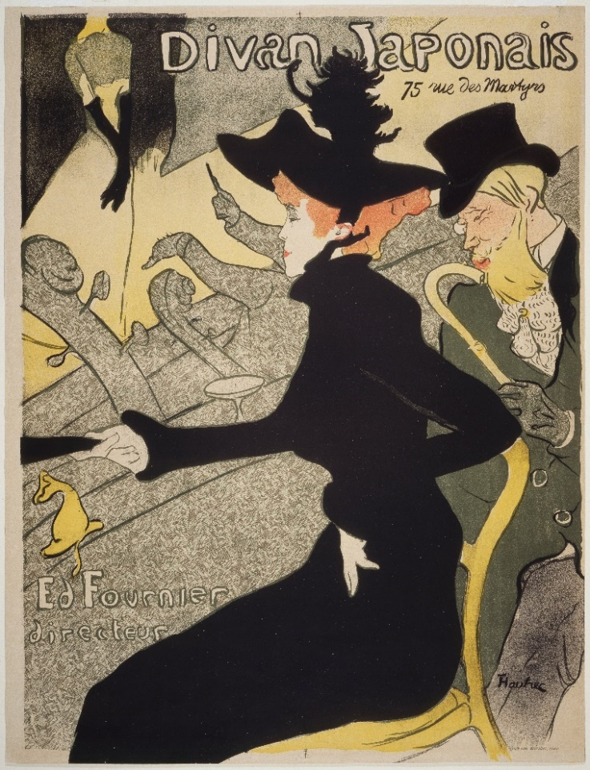  
**Figure 8: Henri de Toulouse-Lautrec - Divan Japonais 1892- source: Google Art Project**

The birth of the modern manifesto was also possible during the second half of the nineteenth century because several tools that allowed the overcoming of the traditional local areas of commerce, such as shop windows, commercial galleries, favouring the use of images. As a result, they also encouraged advertising posters to adopt a visual language based on images (Codeluppi 2012, 56).

This innovation has led to the birth of the "poster-brand": a modern conception of the poster, which provides a graphic image that can communicate the essence of the product and make it memorable.

It is important to remember that many of the artists who were specialized in the creation of posters set up their studios. This is why, until the end of the nineteenth century, advertising posters had characteristics that still kept them connected to the typical painting practice.

In the nineteenth century, what we can call "modern advertising" appeared for the first time because the new poster languages began to establish themselves in the urban space. The advertising poster has always used the external space of the city as a stage on which to express itself. But it became evident especially in this century, when the progressive development of industrialization changed the public squares and streets of the city centres, that they have turned into the fundamental place of expression of advertising communication. Hence the poster began to use images and invaded cities with increasingly large formats (Codeluppi 2012, 55). The walker, therefore, had to get used to reading increasingly surprising "street pictures", posters that were new communicative subjects designed to fit firmly into the urban scene (Codeluppi 2001, 19).

The increasing use of new fast vehicles forced to learn to see such posters more and more quickly. subsequently, the vehicles themselves as the tram began to be a tool for displaying posters. Advertising during this period not only increased its size but also multiplied the places where it appeared, starting a process of progressive invasion of urban and social areas that has not yet ended (Codeluppi 2013, 25).

In the most significant posters of the early twentieth century, we also find the echo of the important artistic movements of the time (Cubism, Futurism) and the most advanced artistic techniques, such as photomontage. The Futurists, indeed, were the first to establish harmony with the new industrial world, understanding the innovative nature of advertising communication and the strong connections between industry, advertising, and the production of forms of expression (see Figure 9).

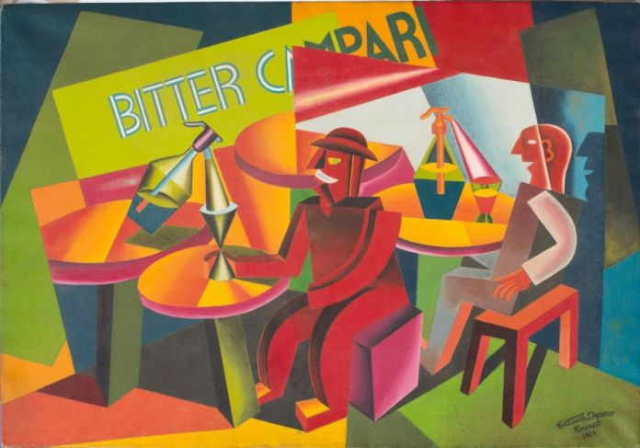

**Figure 9: Fortunato Depero, Squisito al selz, 1926. Copyright: Michele Scudiero**

**Source:** <https://www.artribune.com/arti-visive/arte-moderna/2019/06/mostra-fortunato-depero-lucca/>

## **1.4 Period of consolidation**

The expansion of the economy and consumption caused by the second industrial revolution has made small advertisements in newspapers no longer adequate as a promotional medium. Consequently, a large poster has become a major communication tool (Codeluppi 2001, 27).

Consequently, large posters have become an important communication tool (Codeluppi 2001, 27).

In those years, thanks to the evolution of the marketing culture, a trend in advertising has evolved in favour of an orientation aimed at enhancing the qualities and performance of a specific product not finalized to the generic presentation of a brand or a product.

The need felt by companies is no longer just to let people know that a particular product or company existed, but to make them prefer to the customer.

Therefore, companies start placing their name on the product packaging in order to establish a direct connection with the customers.

Since the beginning of the twentieth century, the use of the term advertising has spread instead of réclame (Codeluppi 2013, 46).

The world of advertising was influenced by the results of new studies conducted by psychologists of the human mind and this led to the creation of more sophisticated posters. Purely artistic advertising or generally oriented to establish a product was replaced by a more rigorous orientation aiming to show and enhance the quality and performance of the goods. The advertising message thus became less immediate but more articulated and complete, more effective in terms of the proposal of a stimulus to purchase (Codeluppi 2001, 23).

In Italy, only in 1907 with the publication of the text "L'arte della réclame" of James Bennet's book, began to spread the idea that the commercial success of a product depends on an adequate advertising campaign that uses, at the same time, different means of communication such as packaging, advertising in magazines, shops (Terenzi 2012, 26).

The most intense phase of change that advertising went through was the 1920s and 1930s. During those years, advertising became a real industrial and communication system that contributed to the creation of a mass culture for the consumer society (Codeluppi 2013, 39).

It is precisely in these years that the poster has reached its maximum expression in Italy. The artists to remember are Leonetto Cappiello from Livorno and Marcello Dudovich (see Figures 10 and 11).

Since the beginning of the twentieth century, the use of the term advertising has spread instead of réclame (Codeluppi 2013, 46).

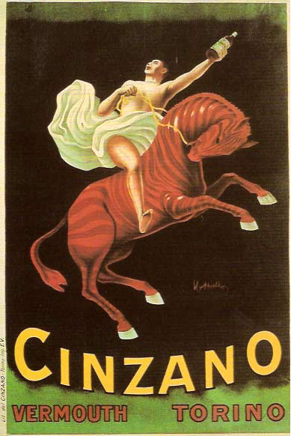

**Figure 10: The poster made for Cinzano by Leonetto Cappiello in 1910. Source:** [**www.italianways.com**](http://www.italianways.com)

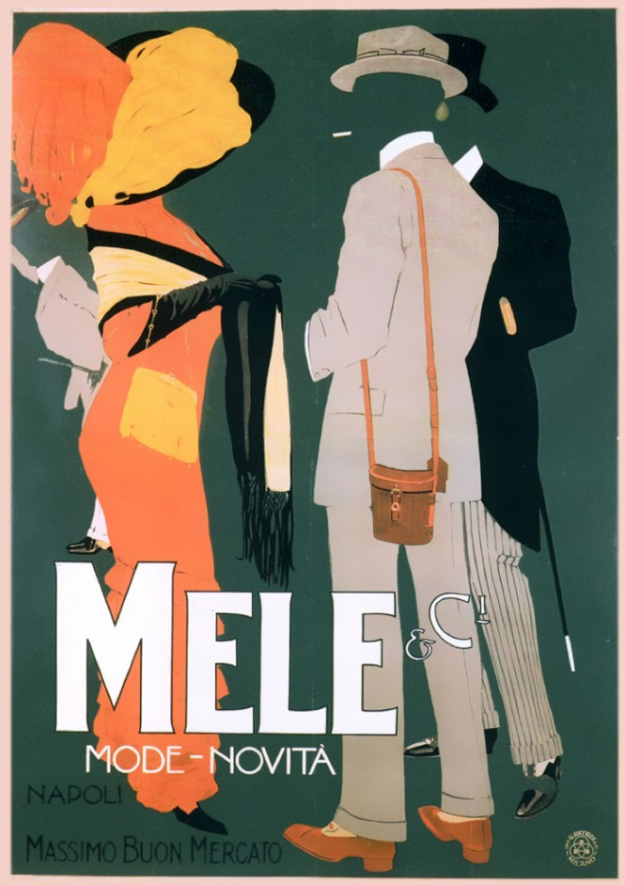

**Figure 11: A poster created by Marcello Dudovich for Magazzini Mele, 1910. Source: www.italianways.com.**

## **1.5 The World War years**

With the outbreak of the First World War, advertising was used to attract volunteers (Tungate 2007, 23).

The years of the Great Wars were characterized by an intense visual communication of political and war propaganda: this assumed an important social role because the levels of illiteracy were very high. In this context, the poster designer acquired further value for the capillarity of diffusion and the directness of the message (Terenzi 2012, 24) (see Figure 12).

It is known that Mussolini has often made use of all the rhetorical and persuasive techniques that advertisers have long used to communicate with the Italian public opinion (see Figure 13).



**Figure 12: Call to arms, American recruitment manifesto. Government Printing Office, ca. 1944. Source:** <https://time.com/4650257/rare-world-war-ii-posters/>

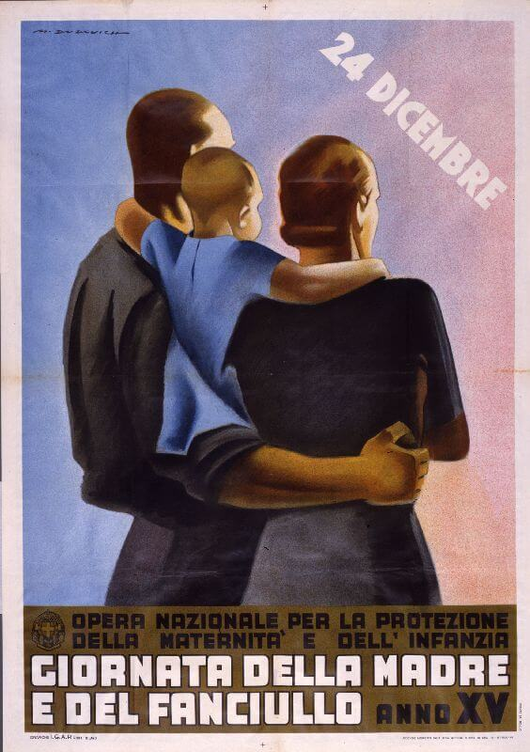

**Figure 13: Use of advertising methods by fascist propaganda. Source** <https://www.dirtywork.it/blog/fascismo-e-pubblicita-la-comunicazione-e-la-propaganda-nella-grafica-pubblicitaria-del-ventennio-fascista/>

In the period between the two wars, Western society took on definitive mass characteristics, and especially due to the presence of totalitarian regimes, it was particularly important as a propaganda weapon. In this new panorama, the tasks of graphic design were defined with increasing clarity: the drawn image was forced to acquire structured technical skills, thus marked the passage of graphics from the artistic and artisan side that had characterized it until now, to the technical and professional side (Terenzi 2012, 26).

The world of advertising was also strongly influenced by the spread of radio devices, especially from the years after the end of the First World War (Codeluppi 2013, 65).

In 1922 the first radio advertisement broadcast in history was of a New York real estate company, while in Italy, radio advertising began in 1926.

Most of the growth in advertising has happened after the Second World War.

## **1.6 Period of business and social integration**

The post-war years were characterized by prosperity in advertising.

After the Second World War, in the United States, as a result of a spectacular mass expansion in the consumption of goods, a period of development came for advertising. In Italy, on the other hand, the critical phase of economic reconstruction began: advertising could only be negatively affected (Codeluppi 2001, 25).

After the war, the roaring '20s were prosperous. The Victorian age was over and the great social experience of the pleasures of consumption began. The modesty was replaced by sexuality and love for the modern. Advertising encouraged the consumer to enjoy life and consumption, this new trend was not only respectable but also expected. The citizen became the consumer and advertising educated the consumer (Montenegro 2017) (see Figure 14).

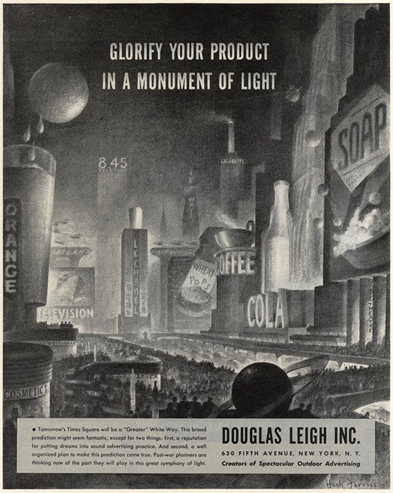

**Figure 14: Hugh Ferris for The Douglas Leigh Advertising Company, 1945. Source:** <https://scroll.in/article/883269/how-post-world-war-ii-advertisers-sold-customers-on-a-future-of-automation>

Once again in the drive for economic development, advertising took a further step forward. The first instances of change were in the United States, where, by the increased efficiency achieved in the management of industrial processes, companies needed to "sustain" consumption in order to prevent a surplus from being generated. That change required advertising agencies to acquire new skills, restructure their organizations, and make significant investments in talent and technology. Then, when television replaced radio, the advertising industry again redefined its mission and sought a new and profitable direction. More recently, the emergence of media conglomerates, cable television, and interactive media has altered the advertising landscape (Jef Richards, Terry Daugherty & Kelty Logan 2009, 14).

## **1.7 The Fifties**

Compared to previous years, were designed more colourful compositions, photographic images, and clear representations of the product and brand (see Figure 15 and 16). The graphic style is enriched by the novelties that come from the purely artistic field. In the United States, Pop-Art is being born and in the following years, it will give a decisive impulse to the development of visual communication.

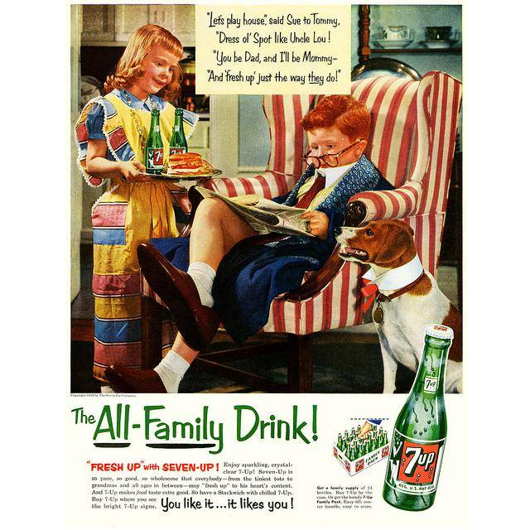

**Figure 15: 7Up (1954). Source:** <http://neatdesigns.net/1950s-20-fabulous-ads-from-the-golden-era-part-1/>

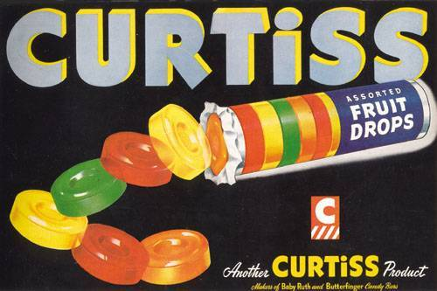

**Figure 16: 1947 Curtiss advertising. Source:** <https://flylib.com/books/en/3.65.1.59/1/>

The first television commercial was broadcast in America in 1941 and was about a Bulova. The main idea has created an advertisement that recalls those illustrated but has the advantages of sound and movement, typical of television. At the end of the 1950s, Italian television also began to broadcast advertising messages in a unique way than the other country. Advertising was allowed, but only within a dedicated space, "Carosello" (see Figure 17).

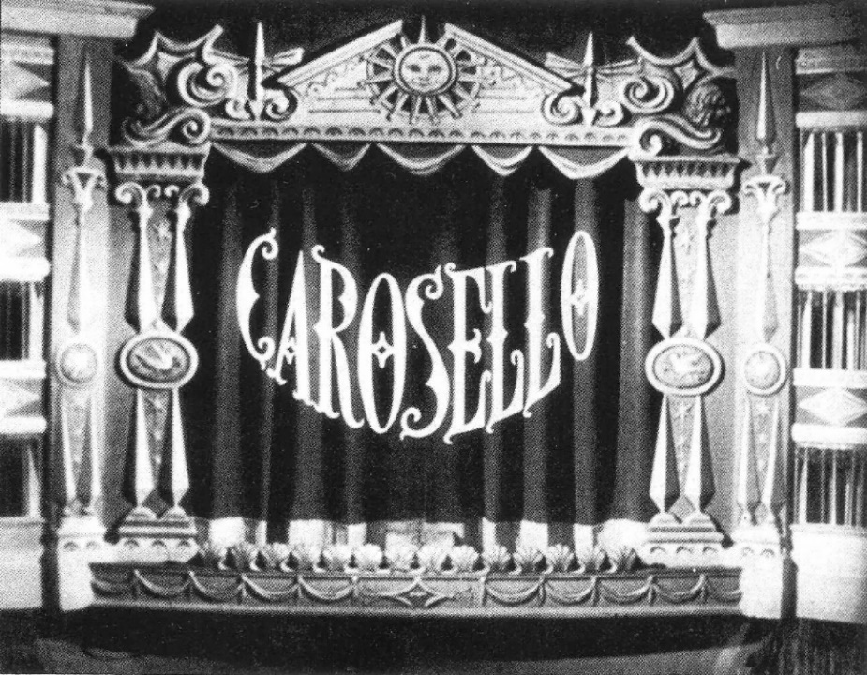

**Figure 17: Sigla carosello- Source**:<http://www.tgcom24.mediaset.it/televisione/speciale-amarcord/carosello-compie-60-anni-un-tuffo-nel-passato_3055000-201702a.shtml>

Advertisers began to identify markets by demographics and users of products. Television split into hundreds of channels, while in the past, there had only been three networks. Magazines began to be published that tailored to special interests and newspapers added freestanding inserts so readers could choose what they wanted to read (Montenegro 2017).

These advertisers could demonstrate the use of their products and services and present well-known figures to praise goods. They also could arrange emotions through television.

Over time, advertising assumed an important position as a means of mass communication in industrial societies.

## **1.8 The seventies: after the economic boom**

After the years of the economic boom, however, the world of advertising faced an economic and cultural crisis in all industrialized countries.

Companies began to need to implement aggressive commercial policies, acting more massively on advertising leverage. Every advertising campaign has to offer only one benefit to the consumer, which the competition does not or cannot offer and which must be sufficiently strong to drive millions of consumers to buy.

In parallel, the climate of social and cultural freedom that was growing in the country also made original productions possible. Advertisers exploited the dominant ideologies of the time by including them in their advertising messages (Codeluppi 2001, 30).

For example, the advertisement created in 1972-73 by Pirelli for Jesus jeans: one of the most original advertisements in the history of Italian advertising. (Codeluppi 2001, 31) (see Figure 18).

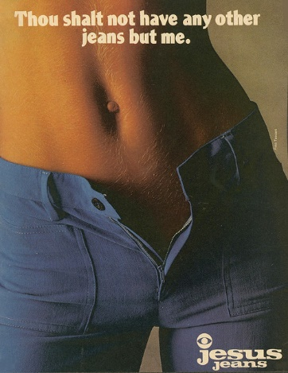

**Figure 18: Pirelli per jeans Jesus- 1972. Source:** <https://www.buukit.com/pubblicita-mi-ama-mi-segua-jesus-jeans/>

The development of the Italian television system, and in particular of private and commercial television, increased the space available, which allowed many new users, even those with smaller budgets, to use the television medium. The consequent increase in users led to significant growth in advertising investments.

## **1.9 The eighties**

Following years, the cultural trends of the time and the graphics are inspired by the suggestions that come from the "Hippie" world: typefaces become rounded and irregular, colours and shapes become "psychedelic" (see Figure 19). Besides these aspects in the eighties, there was, from points of view, a return to a more regular, schematic style, with the addition of shades in colours and "glossy" to increase a three-dimensional effect. In terms of language, after the crisis phase of the seventies, advertisers were able to find the courage to express themselves in total freedom and inspired by the parallel expansion of the television medium and its lively programs, they often tried to assign to advertising a spectacular character.

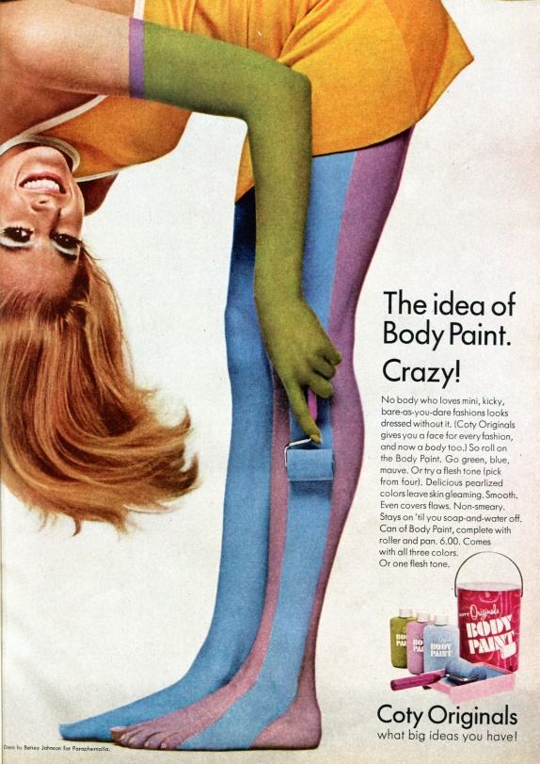

**Figure 19: 1967, advertising with reference to hippie culture of the time. Source:** <https://www.vox.com/2015/5/18/8611549/mad-men-ads>

In the sphere of advertising, the eighties saw the introduction of the first studies of semiotics applied to advertising communication. The messages are no longer descriptive but tend to speak more ideally about the "world" they want to represent; the famous slogan "Milano da bere" can be an example (see Figure 20).

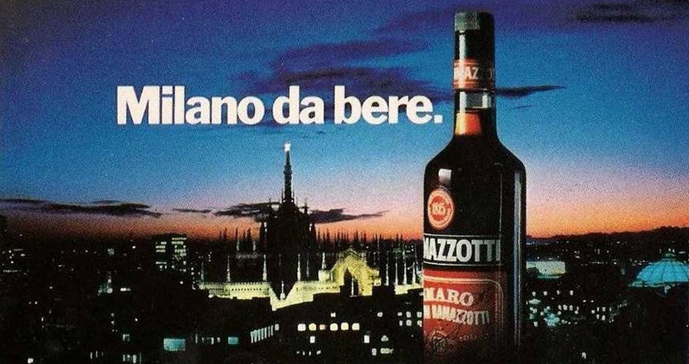

**Figure 20: Advertising of the Amaro Ramazzotti by Marco Mignani, 80's. Source***:* [*https://www.ilpost.it/2019/03/08/milano-da-bere/*](https://www.ilpost.it/2019/03/08/milano-da-bere/)

The massive development of the Italian television system, especially the innovative form introduced by televisions, led to explosive growth in investment in advertising (Codeluppi 2001, 33). The television language first and then the internet, have made verbalism inefficient due to its slowness of communication and rigidity. This peculiarity forcing to develop graphic aspects, in a sort of linguistic iconism: a hybrid between word and image (Codeluppi 20013, 163).

In the early 1980s campaigns, also emerged an extreme attempt by advertising in the newspapers to maintain, playing with language, the cultural predominance that it was losing due to competition from television (Codeluppi 2001, 37) (see Figure 21).



**Figure 21: The Nestle advertising from 1985. Source:** <http://neatocoolville.blogspot.com/2012/04/two-1980s-candy-baseball-ads.html>

Advertising had reached its highest level of splendour thanks to the baby-boomer generation, which had produced the most uncontrolled consumerism in the 1980s (Ambrosio 2005, 20).

Modem advertising is largely a product of the twentieth century. The development of technology and research has led to increased sophistication in advertising in recent decades. During ancient and medieval times, advertising came if measured by present-day standards, however, the reason for using advertising was the same then as it is now.

## **1.10 Online Advertising**

In the early twentieth century, the protagonists and the rules of the game began to change. A fundamental change in the evolution of modern advertising concerns the choice to communicate to the public a real philosophy of life, connected to the use of their products and the ostentation of their brand (Ambrosio 2005, 22).

To guarantee an efficient type of communication: a new way of research was needed, more flexible, fluid, able to reach the most hidden corners of contemporary society (Ambrosio 2005, 22).

The next medium for advertising was the personal computer in the late 1970s and the Internet in the mid-1990s. The ubiquity of the Internet revolutionized the ways people would come to consume content and purchase goods on a massive scale. The opportunities for advertising were

(and remain) virtually unlimited, and the advertisers and media agencies would have to begin to adapt to this revolutionary.

The first online advertising was through spam email on May 3, 1978. The first clickable online advertising was sold in 1994 by Hotwired, which was a digital publication of a wired magazine. Hotwired set aside portions of its website for advertising and sold the ad spaces to advertisers which were called ‘Banner Ads’ (see Figure 22).



**Figure 22: The first banner of the AT&T phone company and appeared on HotWired. Source:** <https://www.ilpost.it/2017/04/27/primo-banner-web/>

In 1994, cookies were introduced by Netscape as part of its browser: Mosaic Netscape browser. Cookies help the advertisers to distinguish online shoppers and track user’s behaviour online, thus enabling them to target the customers efficiently. With the addition of cookies, the concept of “target advertising” turned into a reality. It quickly became possible to serve ads on specific websites or subsets of a specific publisher. Using cookies, companies began providing profiles of how users browsed the web independent of a particular website in which the advertising would appear. These capabilities, which are still evolving, provide much more control for both advertisers and publishers in how ads are placed compared to all other forms of traditional advertising.

In 1995, large companies started to get into the online world and spend on keyword-based advertisements. In 1997, pop-up ads were invented, but they quickly became an annoyance to users. Some even call them: the most hated advertising on the internet. Pop-ups are still used, but browsers often stop them from being shown (Reed 2017).

Along with the explosion of search advertising, display advertising grew year over year. This constant growth benefited both the major publishers and the networks.

Entire corporations operated solely on advertising revenue, offering everything from coupons to free Internet access. At the turn of the twenty-first century, several websites, including the search engine Google, started to change in online advertising by emphasizing contextually relevant, unobtrusive ads intended to help, users (Montenegro 2017).

People move in a multi-screen and multi-device scenario, the web hyper-fragments the audience and companies consider how to reach their targets with cross-media communication. Advertising also tends to take from the internet the communicative model of the network. This new phase makes advertising less recognizable because it tends to mix with the flow of messages in which it is inserted (Codeluppi 2001, 44).

It is essential today to be able to create an empathic link with the audience. A connection created based on strong assumptions for effective communication (Ambrosio 2005, 37).

Communication between companies leaves the form of a monologue and turns into a dialogue, in which both parties play an active role. The consumer is not only looking for new and stimulating experiences but also guarantees and certainties, personalized services, and affordable prices (Ambrosio 2005, 50).

In conclusion, advertisers must dialogue with the market and the consumer. To do so, they must use a shared original language. They should differentiate their message to attract attention, for this reason should be important to choose the most appropriate medium and language (Ambrosio 2005, 74).

There is no longer a need for loud phrases or colourful words, but the freshness, a communication that seems human. The conversation is the key to making the brand live and get it into people's hearts (Ambrosio 2005, 113).

The past decade has witnessed a remarkable impact on advertising due to the rapid strides in technology. In the coming decades, there will be much greater consumer involvement and control and some degree of two-way communication. More and more global players will increasingly adjust their strategies to a local market, country-based or region-based and advertising will increasingly acquire a local colour.

The advertising industry, although a few centuries old, has grown by leaps and bounds since the industrial revolution, the growth has been more profound in the 20th century and continues to be so.

# **2. The Book cover**

After analysing the phases of the evolution of advertising and its role, it is necessary to consider the history of book covers taking into account the role it plays in the self-publishing of the book itself, and therefore its affinity with the world of advertising.

The cover has the dual purpose of attracting and informing the reader about the content of the book; so it is considered as a method through which the book advertises itself.

The cover plays a fundamental role in the framework of the book as it is the presentation of the book itself. It is the primary link between the book and the reader and gives objective indications on the content of the book, its author, and publishing house. The relationship between text and image helps the reader find information about the nature of the book, its genre, and its style. Therefore, its realization must be reasoned to ensure a visually pleasing result.

The main role in the final rendering of the cover is the graphic realization of the dust jacket when it is present, or of the cover, that must capture the attention and encourage to open and read a book.

The graphic designer will then decide whether to realize it with the lettering only or also illustrated a typographic solution. Over the years, mainly from the beginning of the twentieth century, with the improvement of different techniques of representation, the cover and the dust jacket have increasingly established themselves as a media of communication that should be in line with the "spirit" of what is the content.

An important parenthesis must be opened on the editorial series: they represent a heritage that dates back to the second industrial revolution, with the birth of the publishing organization.

In the series, the covers have the same layout. The structure remains recognizable and immediately traceable to a specific series, only some details that differentiate one title from another change.

In the design of the cover remains the fact that the designer's objective is to interpret the subject through the graphic and typographical language communicating.

A cover should “summarize” the meaning and atmosphere of the book rather than the content.

## **2.1 The history of a book cover**

Tracing the history of the book cover and the dust jacket, it is possible to notice how the need to preserve the book is the main reason for their birth. Subsequently to the need to protect the books, their development took shape from the necessity to make the text identifiable: a title page internally, the cover, and a dust jacket externally. The top cover, therefore, only later assumes the characteristics, familiar to us, of a decorative and advertising object, aimed at attracting the attention of the potential reader.

Constructing the history of the book jacket, it reveals the interconnectedness of the publishing industry to the world around it (Snyman 2015, 1). The effects of world history can be seen in every aspect of books, not only their content but also their physical form (Snyman 2015, 2). In particular, the cover is a book’s first communication to the reader, a graphic representation not exclusively of its content, but its point in history (Drew and Sternberger 2005, 8).

The book jacket designs act as historical snapshots of the visual culture prevalent during their creation through the selection of typography, use of shapes, style of imagery, and overall mood. Books evolve and will continue to upgrade together with technology and society.

Consequently, when a text is published, the book is designed and printed, it becomes a physical manifestation not just of the ideas of the author, but of the cultural ideals and aesthetics of a distinct historical moment.

Today, the cover is a real marketing object and plays the role of packaging for literature. However, the history of this modest rectangle of paper is rich in lessons, moving from the conservation function of the first manuscripts to the object of great consumption, it animated generations of graphic designers (Guillermou, 14 June 2017).

The book dust jacket was created in the 1830s to keep dirt from damaging the book’s cloth cover and binding. However, during the 1900s, the dust jacket transcended its modest beginnings, evolving into an artistic design medium that captured the aesthetic transformation of design. The ascension of the book jacket into the realm of graphic design and fine art was largely due to the efforts of passionate graphic designers, who dedicated their careers to creating conceptually and visually engaging book jacket designs.

### **2.1.1 The birth of book covers**

In the beginning, books didn't have covers. Initially, books were a privilege for a few people, most of them could not read or write. Those who, instead, read did not have the extensive choice of today and did not have to choose between thousands of tomes, novels, essays: the cover was not important, it did not fulfil any purpose.

Actually, initially there was no reference to cover but binding. For protective reasons, books were often closed with metal or leather clasps until the end of the fifteenth century. They are designed to be laid flat and well protected. Then the clasps go out of fashion and are gradually replaced by strings and finally nothing more, except for some precious books. In the sixteenth century, it is the genesis of the modern book as we know it: without clasp, with a hard cover, smaller format, easier to carry (Guillermou, 14 June 2017).

Until the beginning of the century, bookshops, public or private, the few that existed, bought books in folded and composed but naked, without covers. The publishing industry, in fact, did not bind the books but delivered them to printers and sellers covered only with a light sheet of protective paper; only later they were bound by the bookbindery or by the booksellers themselves, with covers that have the function of distinguishing the owner and standardizing the volumes that make up his library or his commercial enterprise.

Starting from the principle, before the 1450 and during the Middle Ages or the Renaissance, the book was a precious object, each line was handwritten, decorated with gold illuminations, and that the covers are works of art in their own right. Book "covers" was enriched with hand-engraved or embossed bindings, precious stones, ivory, silk, clasps, embroidery, leather, and gold and silver threads (Guillermou, 14 June 2017) (see Figure 1). The cheapest covers were made of parchment, at most with cardboard reinforcement. There were no pictures, no engravings, and the title was rarely shown on the front.

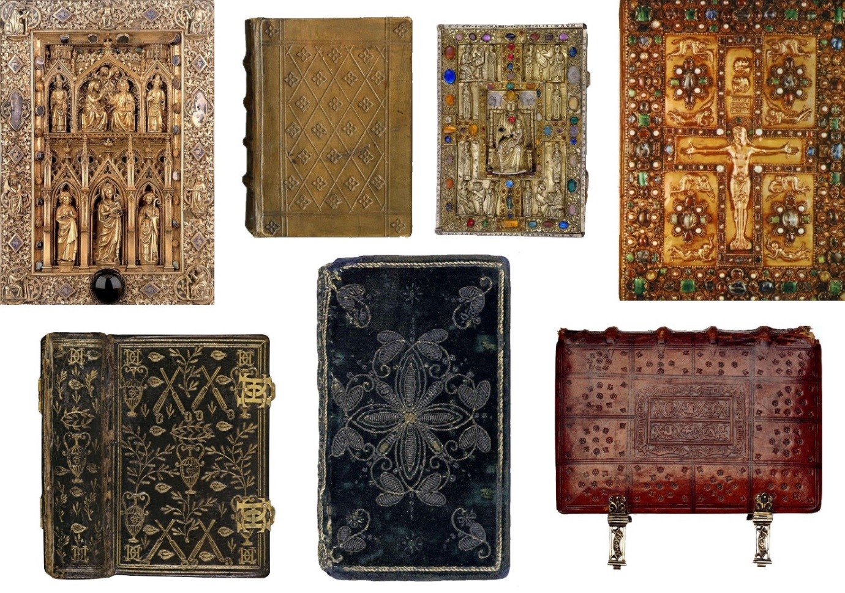

**Figure 1: examples of the first book covers. Source:** <https://www.grapheine.com/en/history-of-graphic-design/history-of-book-covers-1>

They were not covers as they are today. The covers were used to protect the magnificent precious texts, written by hand, and whose paper had to be protected from the deterioration of time and readers. These early versions were simple functional dust jackets, which paid scarce attention to the advertisement about the contents of the books. The most economical dust jackets were discarded by the bookstores upon receiving the books and thus very few of them have survived (Guillermou, 14 June 2017).

Since the end of the fifteenth century, the main vehicle for information is the colophon, located at the end of the book, where details on the content were mentioned: the name of the printer or copyist, the date or place (Guillermou, 14 June 2017).

In these years we see the appearance of more and more books a less precious, with embossed leather covers (Guillermou, 14 June 2017).

### **2.1.2 Book covers from sixteenth to eighteenth century**

Since the sixteenth century, investment of capital in "publishing" companies began to be made, making necessary the search for a profit. The book began to be produced systematically outside the environment where the text was created: this led to a distinction between the author and the producers of the book.

With the increase in the number of printed books, the colophon is less convenient to consult and gradually migrates to the front of the book (Guillermou, 14 June 2017) (see Figure 2).

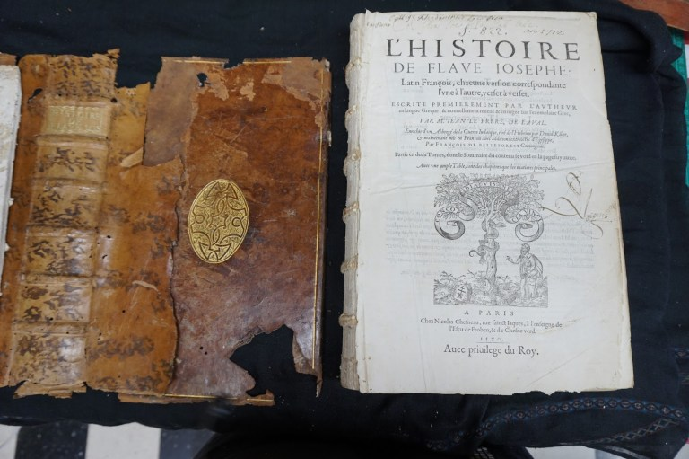

**Figure 2: example of the information appearing on the title page of the book and use of leather covers Source:** <https://www.grapheine.com/en/history-of-graphic-design/history-of-book-covers-1>

In the sixteenth century, the title page was also created: the first page of a book in which part of the information about the text is presented. Although at the beginning it contained only the title, from the seventeenth century, it was enriched with decorative elements, which remained in vogue for little more than a century, until the advent of neoclassical taste that removed the superfluous aesthetic and highlighted the essential information on the text. On the cover, meanwhile, the name of the author was occasionally indicated on the spine, but no other information (Ollister 2018) (see Figure 3).

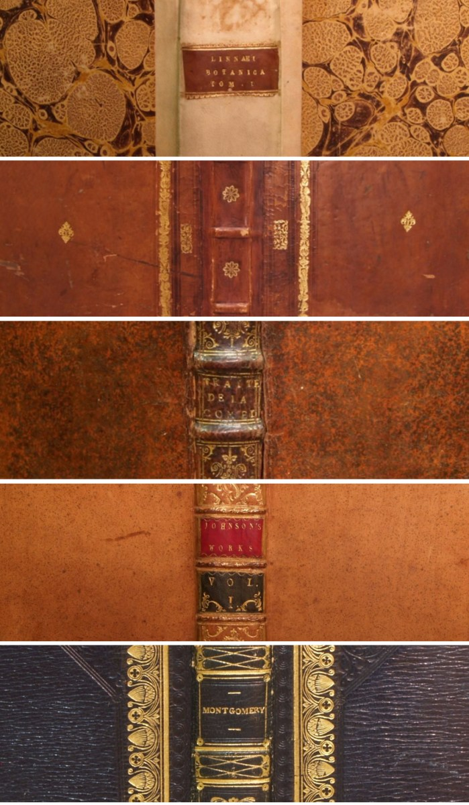

**Figure 3: example of a spine of the book, unique section of the cover where the author's name appeared. Source**: <https://www.grapheine.com/en/history-of-graphic-design/history-of-book-covers-1>

In the seventeenth century, the editorial scenario seems to have changed a lot since the beginning of the press. The book is no longer produced mainly by order. The publisher-bookseller came out of anonymity and imprinted his mark on the products of his shop. The mark was no longer at the end of the text, but on the title page, as a sign of guarantee.

In this period, the book becomes an object-product whose production is increasingly focused on not only textual but also graphic and para-textual aspects. The seventeenth century was also the period in which the figure of the typographer-printer gradually assumed autonomy from that of the bookseller. Consequently, the trade of the bookseller becomes a sort of publisher.

In the eighteenth century, in the most important cities in Europe, readers began to increase. It was the middle class, which was evolving and felt the need to learn. It was precisely in this moment of literary ferment that the need to protect and differentiate books began to be felt.

The evolution of the dust jacket is inseparably related to the development of the cloth bound book, which resulted from population growth. The growing number of middle-class citizens purchasing books prompted the publishing trade to accommodate readers’ desire for affordable books by using more cost-effective materials such as pasteboard wrapped in cloth.

With book production becoming cheaper, the covers needed to be similarly inexpensive. The heavy hand-bound option was replaced with printable, mechanically-bound covers of cloth and paper. Book publishers realized that the front of their books was a valuable advertising space. What followed was the birth of cover art as we know it today.

### **2.1.3 The nineteenth century and the modern book covers**

In the nineteenth century, the "old typographical regime" ended. The trade of the publisher, in the modern sense, was formed. The book product, as we know it today, was already delineated. Publishers began to present their catalogue systematically divided into series with greater attention. Besides, some spaces that still have a function in the book presentation today, such as the cover and the title page, became more precise. In England, the use of protecting the book and its cover with an additional movable layer of paper, dust jacket, is spreading. Shortly, the dust jacket became a presentation tool with great potential. It became established even outside the Anglo-Saxon world.

The dust jacket wraps the whole book, holding on to the cover with two flaps of paper. This is one of the parts that, at least since the end of the nineteenth century, includes a brief presentation of the contents of the book, some statements from favourable reviews and a biographical-critical note on the author. At the end of the nineteenth century, however, the dust jacket still did not have those typical elements of the cover, but mostly the publisher's logo. The idea of developing a special design for the cover had not yet been born (see Figure 4). It would happen, later on, establishing this space and that of the cover as very fertile areas for the expression of graphic art.

It seems that it is in this historical context that English publishers are beginning to use the dust jacket even as a means of showing the belonging of a book to a collection. The idea of the series is not only to indicate the seriality of the releases, but also the editorial project that is the basis of the series itself. Thus guaranteeing the reader the next title and building the conditions for that reader to become a buyer again.



**Figure 4: 1820, the oldest known dust jacket of the German two volume Neues Taschenbuch von Nürnberg. Source:** <https://www.biblio.com/book-collecting/basics/a-brief-history-of-the-dust-jacket/?fname=a-brief-history-of-the-dust-jacket>

In 1820 there was the Great revolution. Thanks to machines and presses, the book creation process is becoming simpler, faster and cheaper. Immense progress was made in terms of printing techniques (Guillermou, 14 June 2017).

The new iron press technology reduced the production costs of books, but the leather bindery was prohibitively expensive.

To reduce costs, publishers decided to substitute the leather with cloth, but finding a durable cloth that could compete with leather was a major barrier. The industry found a suitable variety of cloth by the 1830s so that the cover design could be printed directly on the cloth bindings. Applying metal blocks, which were used to stamp designs on leather in the past, publishers began to transfer the cover design on the cloth bindings in the late 1820s. Cloth cover binding was now as versatile as leather, in blind, ink, and even in elegant gilt. With the mass production of books, the cover design gradually evolved, and the designers used various elements of design and typography to enhance the readers to purchase a book (Novin 2016).

This innovation is addressed to powerfully influence the fortunes of modern publishing. From now on, publishing binding became the standard. The leather is therefore increasingly often combined with cloth-covered cardboard. The difficult availability of cotton during the years of the American Civil War and the formation of a public interested in an immediate, temporary and voracious use of the book, rather than the cult of the precious and collectable object, led to the increasingly widespread use of cardboard and paper (paperback) instead of fabric. With the surprising novelty that cardboard, born as a temporary solution while waiting for a more resistant binding, becomes instead the definitive dress of the modern, typographic and illustrated, advertising book.

From 1820, printers changed their manufacturing processes and began to market books with the cover included. To make them more attractive, these covers were illustrated. At first, these illustrations were simple drawings, monochrome and easy to print, representing basic geometric shapes (Britt Sas 2011).

Before seeing the cover illustrations as we know them today, publishers used watercolour inlays in silk or tissue paper packaging half illustrations/half teasers announcing the next volumes to appear (Guillermou, 14 June 2017) (see Figure 5).

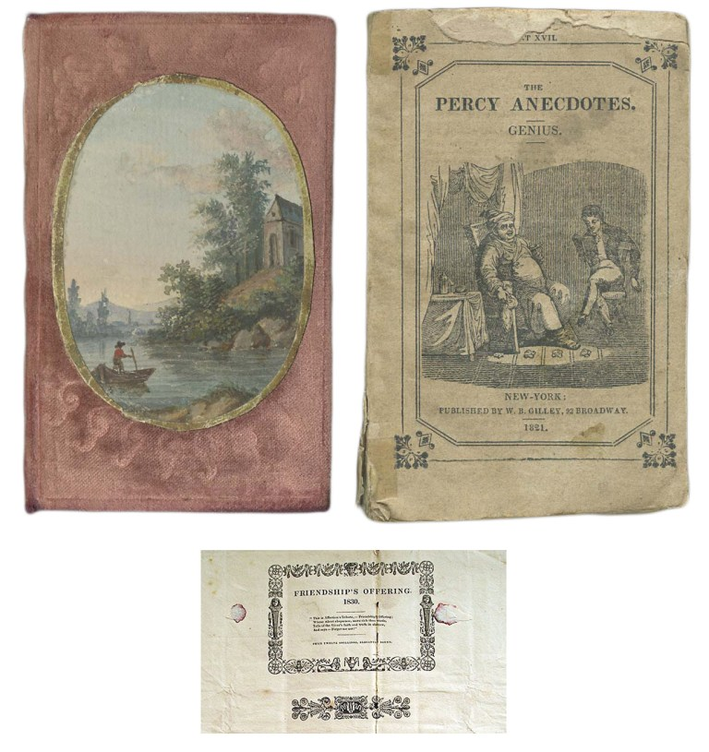

**Figure 5: example of watercolour inlays in silk (left, 1818) and tissue paper packaging (right, 1821). Source:** <https://www.grapheine.com/en/history-of-graphic-design/history-of-book-covers-1>

The field of book covers has gradually been taken over by poster designers and other fashionable artists. This period coincides with a rise in what will later be called "graphic design": the illustrators have gradually specialized, and have gone from pure artists to artisan illustrators. Consequently, around the middle of the nineteenth century, with the Industrial Revolution and the birth of the consumer society, the new needs for reading related to commuting and mass rail transport imposed new requirements for use: the protective function of the cover was combined with the search for an attractive presentation of the book.

From 1840, embossed or gold illustrations on fabric became more and more common to highlight the contents of the book, and the title gradually appeared on the front of the book, alone and in the middle of the cover. Most of the jackets used typographical designs in plain coloured, with no illustration other than a decorative border around the title, sometimes printed in red. Some carried advertisements, that were usually printed on the back of the book. The majority of them were for other books by the same publisher, most of the time of the same genre or by the same author but occasionally there would even be an advertisement for “soap or soda water” (Snyman 2015, 3). Fabric replaced leather, and by the end of the nineteenth century it had completely taken over the cover monopoly. (see Figure 6, 7, 8)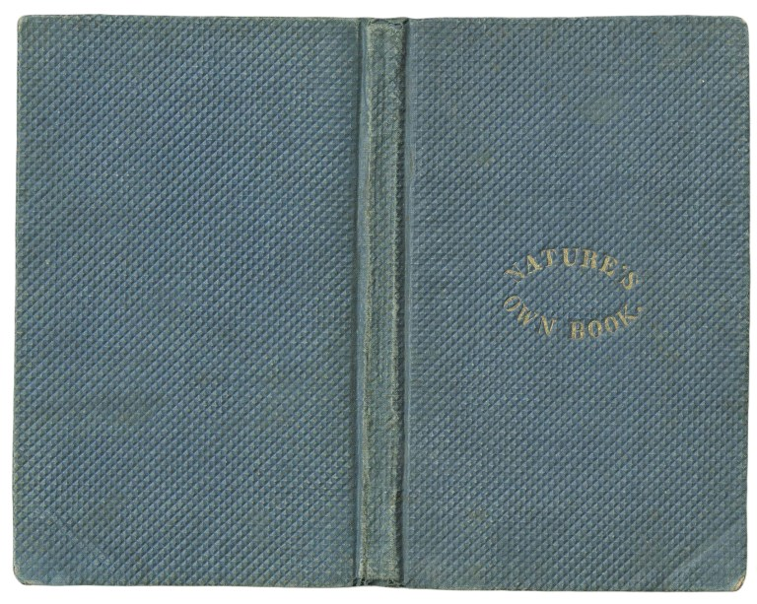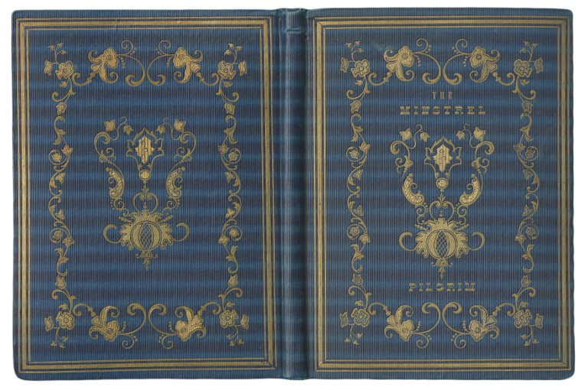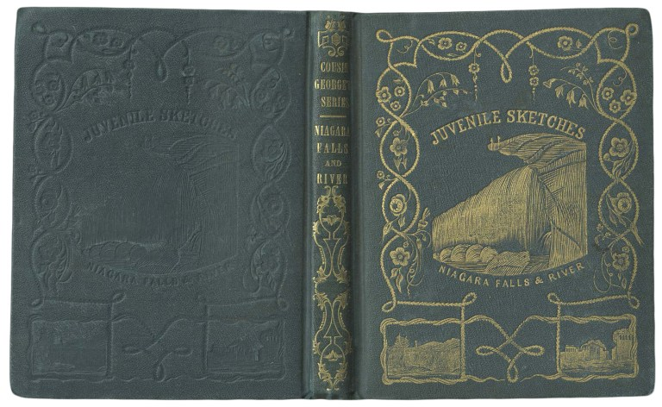

**Figure 6,7,8: Typical covers of the years 1840 – 1855.**

**Source**: <https://www.grapheine.com/en/history-of-graphic-design/history-of-book-covers-1>

Over the years appeared more and more complex illustrations: the books were beautiful, they offered themselves, the cover no longer serves only to protect the page inside; it took the function of advertising and also described and illustrated their content of the book: it is the real birth of the cover (Guillermou, 14 June 2017).

The polychromic revolution in printing in the 1860s marked the advent of graphic design, with the rise of illustrators who specialized and became real stars in the field. Publishers understand that the public is attracted to images: they help to sell the books better. As a result, the removable covers gradually disappear, as the covers started to be decorated with designs and colours (Guillermou, 14 June 2017).

During 1840 and 1860 the ancient practice of art binding revived in its pre-industrial, medieval and neo-gothic essence: first, decorative, stylized and geometric later. This time was not made directly of ivory or leather as in the past but of papier- mâché thanks to specialized machines and presses imitating Gothic letters. Unlike the manual work of the Middle Ages, this kind of result could be reproduced in series (Guillermou, 14 June 2017) (see Figure 9).

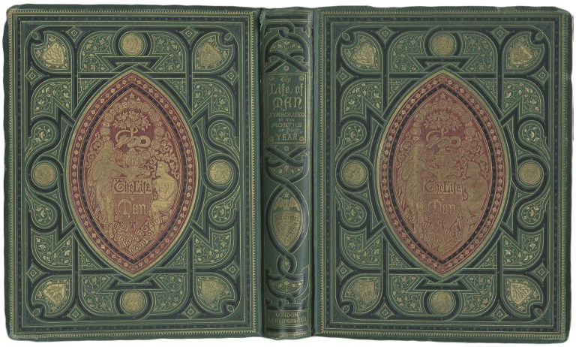

**Figure 9: 1860-70 Cover example. Source**: <https://www.grapheine.com/en/history-of-graphic-design/history-of-book-covers-1>

On the covers, leather and fabric (especially silk) returned, then replaced, in the Futurist period, by materials such as iron and tin.

From the colophon to the title page, from the frontispiece to the top cover, from the flaps to the bands: the space for the information component of the text is expanded and enlarged to follow the needs of the market. It should not be forgotten that the cover is the responsibility of the publisher, who is the commissioner.

Less than a century later under the influence of Japan, France or Russia, the covers of books did not stop to evolve with technical progress and crises. They alternately assume a purely aesthetic function before becoming support reserved for the greatest artists. As early as the middle of the nineteenth century, illustrations were put forward in the press thanks to the wood engraving technique brought back from Japan or lithography. Especially in 1890, the Japanese influence opens perspectives on new illustrations or more asymmetrical layout styles, and on a polychrome wood engraving (see Figure 10).

In 1876 Lewis Carrol in a letter to his publisher recommended to print the title of his book "The hunting of the snark" also on the coast, to make the book "cleaner and more saleable" and also make it recognizable on the shelves. It is an example of how, in the second half of the century, the authors discovered the empty space around the book and that could be used to communicate and present the content (See Figure 11).

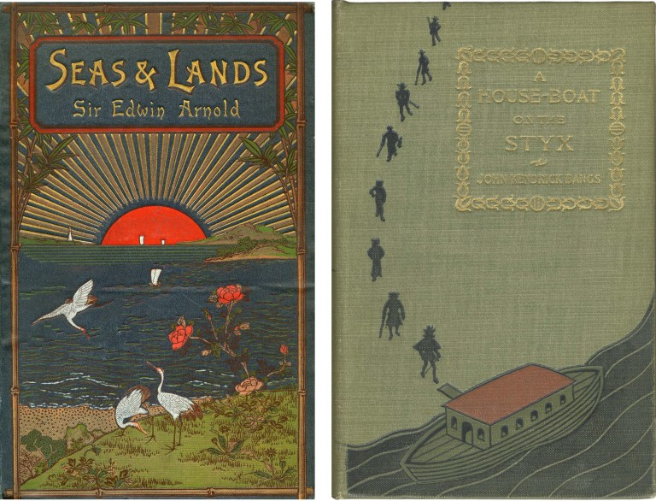

**Figure 10: example of Japanese influence. Source:** <https://www.grapheine.com/en/history-of-graphic-design/history-of-book-covers-2>

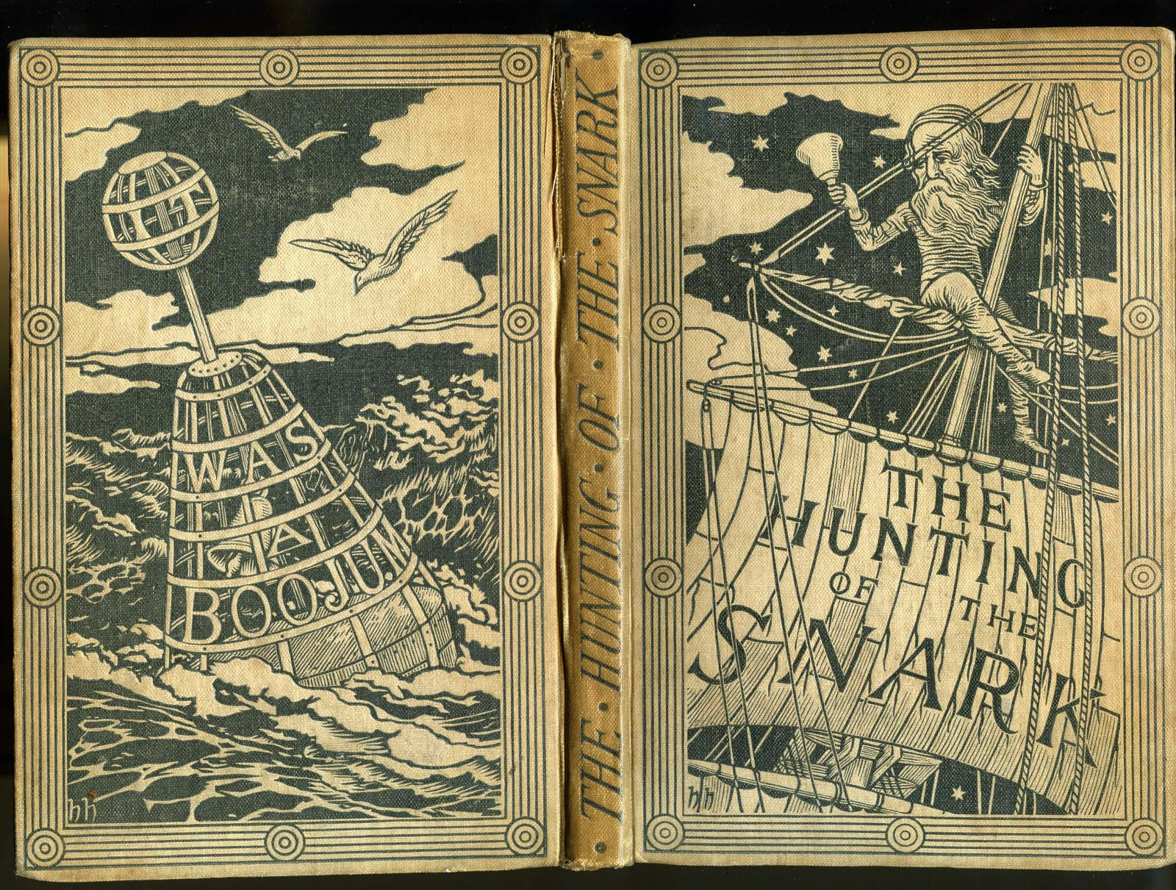

**Figure 11: 1876, cover of the hunting of the snark. Source:** [**https://pplspcoll.wordpress.com/2010/01/13/hunting-of-the-snark-revisited/**](https://pplspcoll.wordpress.com/2010/01/13/hunting-of-the-snark-revisited/)

Late 1800, early 1900 is the golden age of illustrated magazines, and publishers have understood that images sell. From 1870 and for twenty years, the symmetry of the layout was abandoned, in favour of motifs built around an aestheticism that was more graphic than systematic (Guillermou 29 June 2017). The majority of books are always protected by a paper cover, which takes the visual of the hardcover, applied on fabric.

Russian artist Aleksander Rodchenko and English illustrator Aubrey Beardsley were among the most influential early book cover designers. Beardsley created artwork for Henry Harland's popular "Yellow Book" series of the 1890s (Novin 2016) (see Figure 12).

The "Yellow Book" marks the beginnings of the era of the cover of the modern book (Guillermou 29 June 2017).

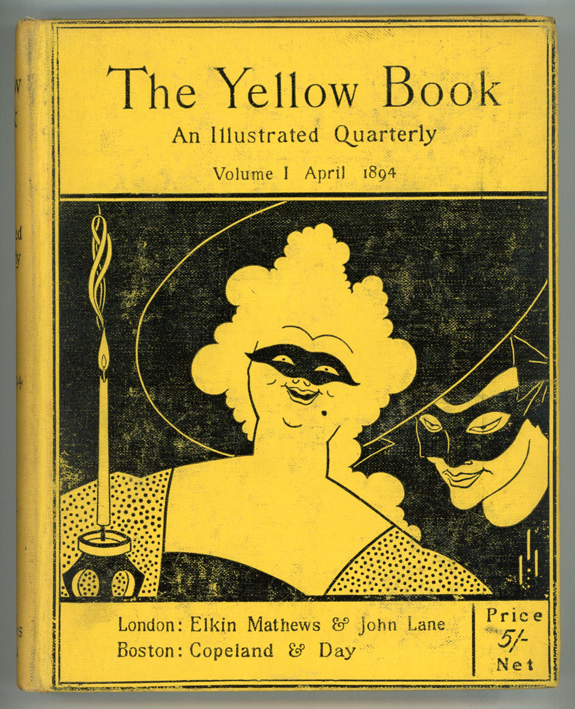

**Figure 12:1890 Cover example of Aubrey Beardsley. Source:** <https://www.lwcurrey.com/pages/books/154894/the-henry-harland-yellow-book-an-illustrated-quarterly-literary-art-aubrey-beardsley>

In the same period were famous also the "Paperbacks", "Yellowbacks" or other "Penny dreadfuls" (in Great Britain), printed without frills and at a lower cost and entirely in paper, without a hardcover, and in a smaller format, the “Yellowbacks” can be found in every station (see Figure 13).

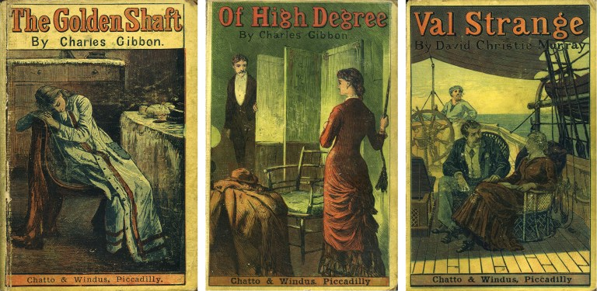

**Figure 13: example of yellowed cover. Source:** <https://www.grapheine.com/en/history-of-graphic-design/history-of-book-covers-2>

The yellowed covers that give their name are made of poor quality wood. In a few decades (between 1860 and 1880), the graphic design moved from a golden and symmetrical monochrome to a truly golden age of colour illustration, creative and innovative (Guillermou 29 June 2017).

As regards Italy, one of the first examples of modern covers dates back to 1870 and consisted in the realization of a blue paperback of “Storia di una capinera” by Giovanni Verga (see Figure 14).

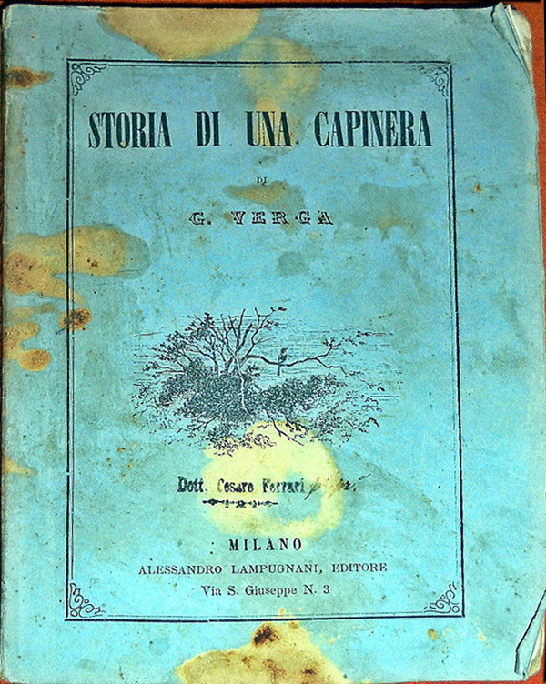

**Figure 14: 1870, first cover of “Storia di una capinera” by Giovanni Verga. Source:** [**https://www.ilpost.it/2017/02/06/storia-delle-copertine/capinera/**](https://www.ilpost.it/2017/02/06/storia-delle-copertine/capinera/)

During the 1890s progressive European publishers transformed the dust jackets from a throw-away piece of packaging into art that screamed ‘buy me’ (see Figure 15).

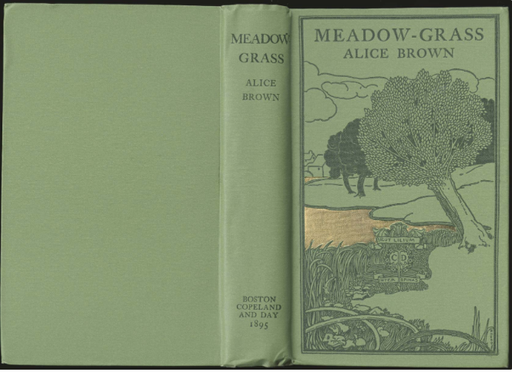

**Figure 15: 1895 cover example. Source:** <https://rbscp.lib.rochester.edu/3348>

### **2.1.4 Cover books in the 20th Century**

In 1906 the importance of jacket design for marketing purposes began to become apparent. When examining pictorial jackets of this historical period, it becomes clear that the images on book jackets were mostly illustrations inspired by the story described in the book. In 1913 publishers seemed to realize the importance of design and quality of book jackets to provide information to their customers, gradually the designers became more specialized, and the paper used was more robust than that of the previous century (Snyman 2015, 5) (see Figure 16, 17).

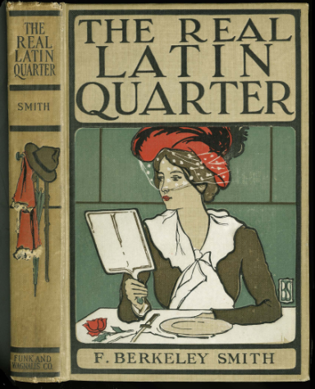

**Figure 16: 1901 cover example. Source:** <https://rbscp.lib.rochester.edu/3348>



**Figure 17: 1903 cover example. Source:** <https://rbscp.lib.rochester.edu/3348>

The decisive improvement in editorial graphics came in the period before and after the Great War with the development of the first historical avant-gardes, which allowed visual experimentation in the coming period.

After the beautiful era of Art Nouveau, the Yellow Book, the First World War breaks out dragging illustrators into his troops. They were called to produce propaganda works, to mobilize men and women to the great cause.

In the post-war era, the book industry had started to become commercially competitive. Book covers were being used as vessels to express the style, genre and subject of a book. Designers were still trying to push the design to its limit in expectation of attracting more sales.

For the book covers, the reference style changes from a Japanese or Art Nouveau influence, realist and contemplative, to strong graphic features with cubist and abstract accents inspired by Soviet and German artists of the 1920s. Symbolism and cubism then reign as masters. The full colour makes its entry (Guillermou 29 June 2017) (see Figure 18, 19).

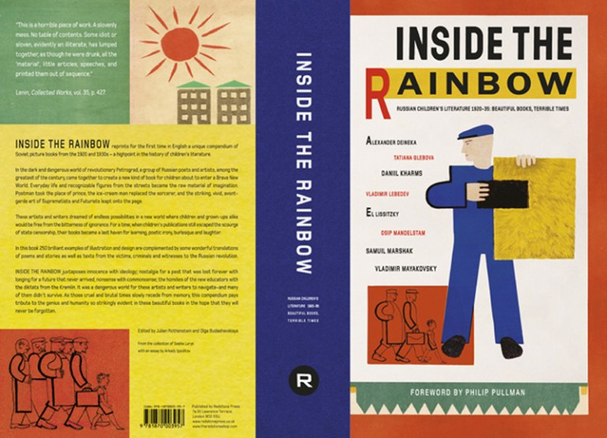

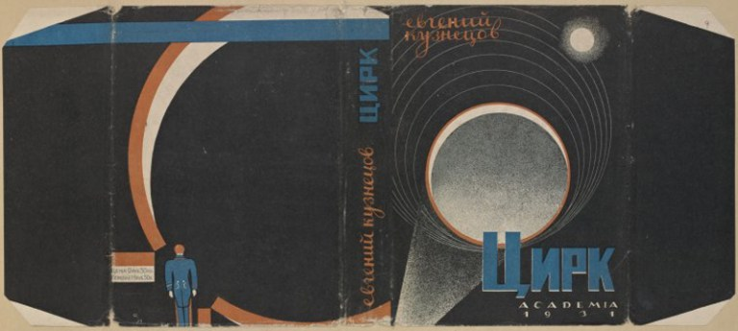

**Figure 18, 19: Examples of covers that are inspired by the cubist and Soviet style. Source:** <https://www.grapheine.com/en/history-of-graphic-design/history-of-book-covers-2>

As in today’s world, the cover design differs from country to country because of tastes that differed from culture to culture. They began to produce books in different ways according to the countries and cultures to which they were addressed: the same book could be associated with images which are so different that the text itself was transformed.

Towards the end of the 19th century, due to the rise of technology and the rise of audacious graphic styles, the design of book covers changed completely.

Later, after the two World Wars, the book covers adopted the advertising aspect similar to movie posters of the time (Guillermou 29 June 2017).

The 1920s and 1930s marked the end of the era of illustrated bindings. After the war, for economic reasons and with the evolution of fashions, the direct printing of fabric became too expensive to decorate books. The illustrations migrate from the fabric binding to the paper jacket. These last ones, formerly used as simple protections, take little by little the advantage on the rigid covers.

Unlike the dust jacket, the paperback book cover was an integral part of the book itself. While the paperback was never intended to have the longevity of the hardcover, its integral cover did eventually help encourage designers to think of the cover design as something more than a protective and marketing device (Drew and Sternberger 2005, 40).

By the 1930s and 1940s, it becomes clear that the book jacket was an important part of the marketing strategy of many publishers (Snyman 2015, 8). Publishers recognized that a stylish book cover could attract consumers, as they are more beautiful than hardcovers, the people start to keep them and not to throw them away. This is one of the major revolutions in the graphic evolution of book covers (see Figure 20, 21, 22).

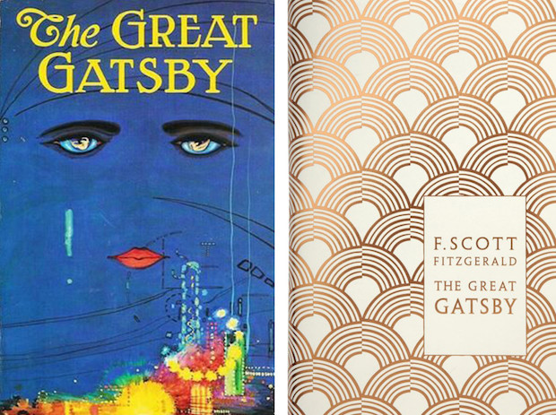

**Figure 20, 21: on the left a 1925 cover example: the cover of the first edition of The Great Gatsby. On the right 1930 cover example. Source 20:** <https://blog.flipsnack.com/the-evolution-of-book-cover-design/>

**Source 21:** [**Drew Ned**](https://www.giuntialpunto.it/search?bnid=411663031&asort=Relevance&bt=Autore%3A%20Drew%2C%20Ned&adv=author%3DDrew%2C%20Ned) **and** [**Sternberger, Paul**](https://www.giuntialpunto.it/search?bnid=411663031&asort=Relevance&bt=Autore%3A%20Sternberger%2C%20Paul&adv=author%3DSternberger%2C%20Paul)***, By Its Cover: Modern American Book Cover Design*, New York,** [**Princeton Architectural Pr**](https://www.giuntialpunto.it/search?bnid=411663031&asort=Relevance&bt=Editore%3A%20Princeton%20Architectural%20Pr&adv=brand%3DPrinceton%20Architectural%20Pr)**, 2005.**

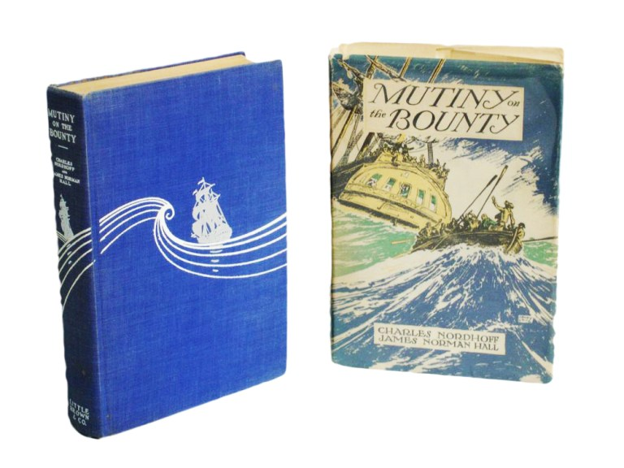

**Figure 22: example of a dust jacket more embellished than the cover itself. Source:** <https://www.grapheine.com/en/history-of-graphic-design/history-of-book-covers-2>

The first paperback books were born. It took shape with, among others, the Penguin editions in 1935 (Guillermou 29 June 2017). Since it started, Penguin adopted a radically new approach to typography and cover design, with the aid of graphic designers like Jan Tschichold in the 1940s and Germano Facetti in the 1960s (see Figure 23). The idea, the brainchild of the publisher Allen Lane, was, of course, to produce affordable paperbacks of good books with the artistic cover design that could replace the elegant desirability of hard-covered editions.



**Figure 23: example of Germano Faccetti’s cover. Source:** <https://www.thismarketerslife.it/stories/cover-design-la-storia-dietro-alle-copertine-penguin-books/>

In July 1935, the first ten Penguin books were published. The advent of the Penguins in England in 1935 and of paperbacks in the United States in 1939 brought a new wind to the world of books (Guillermou 31 August 2017,) (see Figure 24).

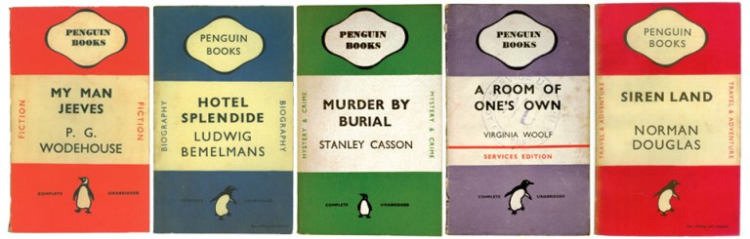

**Figure 24: examples of Penguin editions covers. Source:** <https://www.grapheine.com/en/history-of-graphic-design/history-of-book-covers-3>

Based on Lane's suggestion, the cover design should be minimalistic with a horizontal grid in colours that signified the genre of each book: orange for fiction, green for crime, and blue for biography (Novin 2016). As in the days of Penny-Dreadful and Paperbacks, the book became accessible and available, even to the working classes. The cardboard cover disappears in favour of a simple soft paper cover. However, another important detail changes, the balance between the price and the quality of the book (Guillermou 12 July 2017).

In the same years, the pocketbook in Italy was characterized by a much more traditional structure, where the nineteenth-century title pages still predominate. These were decisions based on elegance, but the volumes were not as attractive as the Penguins of the same years, where innovative colours and graphic structures predominated. The paperbacks in Italy approached the Penguin philosophy only in 1963 when the first Mondadori Oscars were launched (see Figure 25, 26).

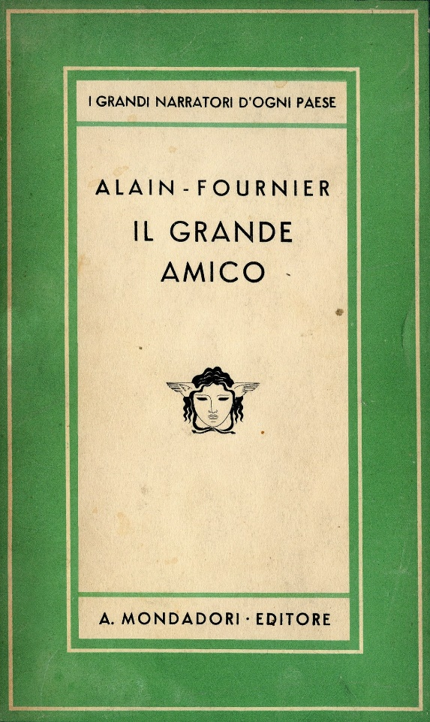

**Figure 25, 26: on the left example of Mondadori cover from 1957 on the right from 1965. Source: Wikipedia**

In a market that was drastically expanding, the pocketbook became an essential product in bookstores in major cities around the world.

In parallel to the beginning of the twentieth century, books continued their graphic evolution, playing with typos and modern compositions (Guillermou 29 June 2017).

Some cult books are adapted to the screen: the covers gradually evolve following the same construction as film posters, especially in the United States in the 1950s (see Figure 27). Photography is not yet in use, and illustrators were still working on advertisements, posters or book

covers (Guillermou 12 July 2017).

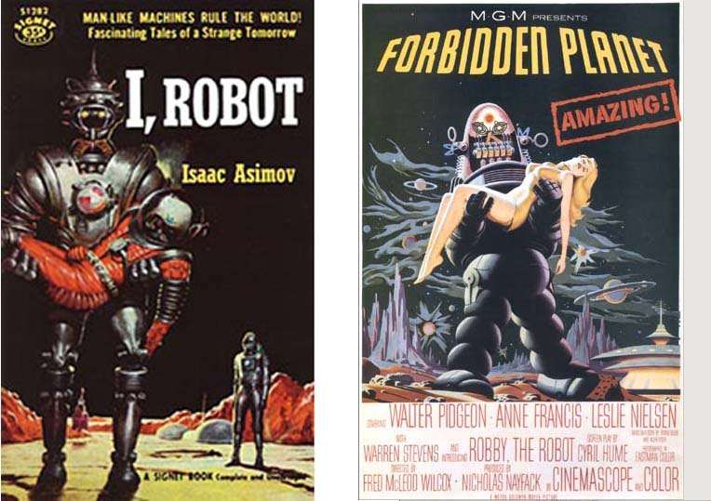

**Figure 27: 1950, example of cover books that appear as movie posters. Source:** <http://cubicmuse.com/?attachment_id=359>

During the 1940s, the majority of book jacket designs used representational illustrations that were merely superficial representations of the general subject of the book (see Figure 28, 29).

After this tendency, when literature began shifting away from the literal and representational style of writing towards a more expressive and figural style, book cover designers began increasingly stressing the mood and atmosphere of the text through the cover design to mirror this change (Guillermou 12 July 2017).



**Figure 28, 29: on the left, 1937 cover example. On the right of c.a 1953. Source 24:** <https://blog.flipsnack.com/the-evolution-of-book-cover-design/> **Source 25:** <https://www.lbi.org/de/collections/rare-books/george-salter-1897-1967-library-book-designs/>

From 1945, graphic design became a profession in its own right. It is the beginning of modern graphic design.

Jacket books designers in the 1950s focused on creating organic and humanistic elements in their covers (see Figure 30, 31).



**Figure 30, 31: on the left 1952 cover example. On the right of 1953. Source:** <https://lithub.com/a-century-of-reading-the-10-books-that-defined-the-1950s/>

It was only around 1960 with the advent of photography, which illustrates magazines and advertisements, that illustrators explore the field of abstraction. Photographic and abstract covers appeared in bookshelves. Colours, layout and typography are an integral part of image communication (see Figure 32, 33).

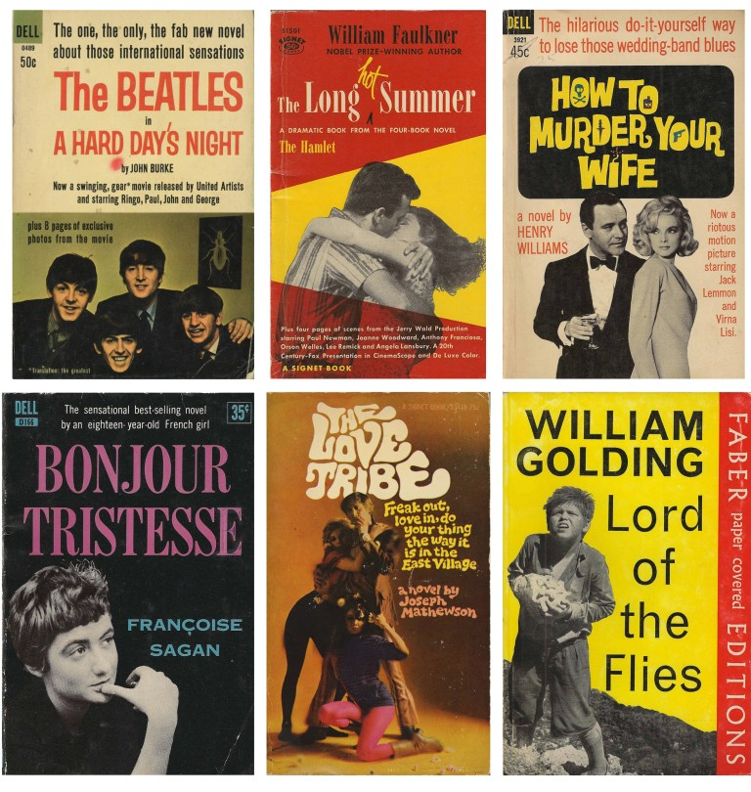

**Figure 32, 33: on the left 1965 cover example, on the right 1964 cover. Source:** <https://www.grapheine.com/en/history-of-graphic-design/history-of-book-covers-3>

Designers, in favour of continuing the Modernist style, used a minimalist approach, reducing designs to a single graphic image or concept (see Figure 34, 35). On the other hand, jacket designers that drew inspiration from past artistic styles created a seemingly disharmonious aesthetic by pulling Victorian fonts, elements of Art Deco, and characteristics of Art Nouveau into a single design. (Guillermou 12 July 2017).



**Figure 34, 35: on the left, 1960 cover example, on the right of 1968. Source:** [**Drew Ned**](https://www.giuntialpunto.it/search?bnid=411663031&asort=Relevance&bt=Autore%3A%20Drew%2C%20Ned&adv=author%3DDrew%2C%20Ned) **and** [**Sternberger, Paul**](https://www.giuntialpunto.it/search?bnid=411663031&asort=Relevance&bt=Autore%3A%20Sternberger%2C%20Paul&adv=author%3DSternberger%2C%20Paul)***, By Its Cover: Modern American Book Cover Design*, New York,** [**Princeton Architectural Pr**](https://www.giuntialpunto.it/search?bnid=411663031&asort=Relevance&bt=Editore%3A%20Princeton%20Architectural%20Pr&adv=brand%3DPrinceton%20Architectural%20Pr)**, 2005.**

Ten years later, book covers are the medium for graphic experiments with typos, colours and abstraction, far from the trends of the mass market that remains mired in paperback covers. The 70s bring their share of psychedelia, flashy colours, art, and a form of freedom of thought that is transcribed in a graphics free from the constraints of the last century (Guillermou 12 July 2017) (see Figure 36, 37, 38).



**Figure 36, 37: on the left 1971 cover example, on the right of 1973. Source:** [**Drew Ned**](https://www.giuntialpunto.it/search?bnid=411663031&asort=Relevance&bt=Autore%3A%20Drew%2C%20Ned&adv=author%3DDrew%2C%20Ned) **and** [**Sternberger, Paul**](https://www.giuntialpunto.it/search?bnid=411663031&asort=Relevance&bt=Autore%3A%20Sternberger%2C%20Paul&adv=author%3DSternberger%2C%20Paul)***, By Its Cover: Modern American Book Cover Design*, New York,** [**Princeton Architectural Pr**](https://www.giuntialpunto.it/search?bnid=411663031&asort=Relevance&bt=Editore%3A%20Princeton%20Architectural%20Pr&adv=brand%3DPrinceton%20Architectural%20Pr)**, 2005.**

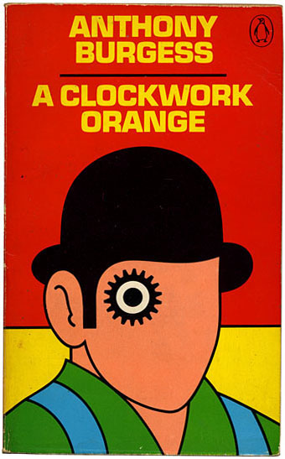

**Figure 38: 1972 example. Source:** <http://www.johncoulthart.com/feuilleton/2012/10/08/design-as-virus-15-david-pelhams-clockwork-orange/>

For the first time, the full texts of novels are available for everyone in pocket format (Guillermou 31 August 2017).

On the other side, it is again the return of the beautiful book, new items appealing to the senses. The new books are well-made objects that do not want to damage in a pocket and enjoy browsing and being surprised by their contents. Readers now want a beautiful item, to rediscover the pleasure of the book (Guillermou 31 August 2017).

As the book publishing industry grew larger and more competitive, publishing houses became more involved in the design process. In contrast to the 1940s and 1950s when designers were recognized as artists, publishing houses of the 1970s claimed authority over the final look of book jackets. Partly due to the impact of colour television on American culture, progressive book jacket designers began integrating multiple, vibrant colours into their designs. Artists, in favour of historic eclecticism, had grown dissatisfied with the rules and rigidity of the past and believed that it offered a new vitality to visual forms.

The design of book jackets in the early 70s has experienced a crisis of innovative and creative design.

However, by the late 1970s book jackets were assigned new life, based on the concept that meaning is interpretative, postmodernist designers integrated a mixture of styles and images in order to create book jackets with multiple possible meanings.

During the 1980s Postmodernist designers continued using historic eclecticism but adopted a collage technique that quickly dominated the treatment of book jackets. Designers often implemented the collage aesthetic to create spatial contradictions between the two dimensional and three dimensional, playing with the reader’s perception of depth on a flat surface. Preserving the spirit of the collage trend, designers favoured design layouts that paired unexpected elements together and required thoughtful interpretation from the reader (see Figure 39, 40).



**Figure 39, 40: on the left 1979 cover example. On the right 1987. Source: Drew Ned and Sternberger, Paul, By Its Cover: Modern American Book Cover Design, New York, Princeton Architectural Pr, 2005.**

Designers of the 1990s searched for ways to reinsert meaning and expression into the design, while still applying a juxtaposition of styles and layering of images to attract the reader. Book jacket designers achieved this by simplifying the collage technique to just a few elements (see Figure 41, 42).



**Figure 41, 42: on the left 1991 cover example, on the right of 1992. Source:** [**Drew Ned**](https://www.giuntialpunto.it/search?bnid=411663031&asort=Relevance&bt=Autore%3A%20Drew%2C%20Ned&adv=author%3DDrew%2C%20Ned) **and** [**Sternberger, Paul**](https://www.giuntialpunto.it/search?bnid=411663031&asort=Relevance&bt=Autore%3A%20Sternberger%2C%20Paul&adv=author%3DSternberger%2C%20Paul)**, By Its Cover: Modern American Book Cover Design, New York,** [**Princeton Architectural Pr**](https://www.giuntialpunto.it/search?bnid=411663031&asort=Relevance&bt=Editore%3A%20Princeton%20Architectural%20Pr&adv=brand%3DPrinceton%20Architectural%20Pr)**, 2005.**

### **2.1.5 Contemporary world and book covers**

The book jacket design styles of the 2000s are best identified by the intent of the design rather than by specific formal elements like previously book jacket. In the visual clamour of a bookstore, the important thing is to be different. One of the preferred marketing strategies of publishers is trying to imitate the design of the last book that sold well in the hopes of attracting the same audience with a feeling of familiarity. In the same manner that the aesthetic of the current book jacket design cannot be explicitly defined, the prevailing twenty-first-century style of illustration cannot be integrated into a single classification. Illustrators and graphic designers alike freely search through a closet of historical styles looking for ones that are adaptable for their purposes for a specific project (see Figure 43, 44).

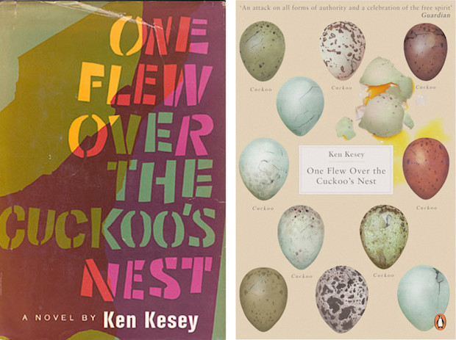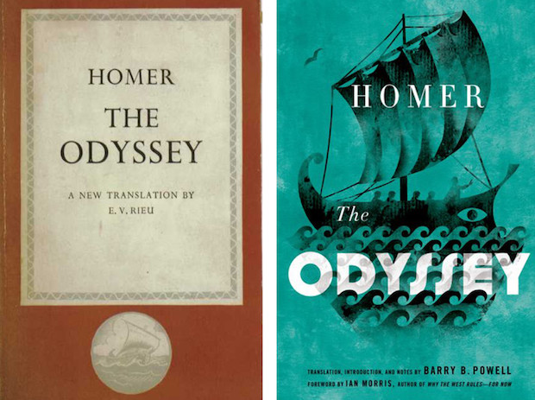

**Figure 43, 44: on the left 2012 cover example, on the right of 2014. Source**: <https://blog.flipsnack.com/the-evolution-of-book-cover-design/>

Book cover design has evolved even more through the rise and growth of the Internet, it is still important, even if it is in a two-dimensional format. The importance of covers in the “e-book business” is even more relevant than in the paper industry. Today, a user wants to understand and enter the information as quickly as possible. E-book covers should still attract more information than printed covers. Until now, e-books had the same covers as conventional books, but faced with the specific requirements of on-screen research and with the expectations of online consumers: the e-book covers very quickly evolved to find a specific language and give more personality to the dematerialized book.

Unlike the traditional cover, the covers of digital books leave less space for details. They must recall the paper content (for those that come from it) while overcoming the constraints of the latter to be readable in digital form. The reader-buyer relationship to these covers is now represented through the single screen. It is with these displays and these consultation modes that we must think when designing covers for electronic books (Sas 2011).

Book cover design, again, much like conventional advertising, has changed significantly. There are three significant aspects in the publishing industry that have impacted book cover design. First, publishers are more aware now not only of the significance of the cover but of its place in society. The images used are now thoroughly recognized as being highly representative of the book itself. Another major shift in book design has been the rise of digital imaging technology, which brought with it new techniques and ease of use. Digital imaging, at its core, made the cover design easier and allowed firms to both create more modern graphical styles and to recreate or imitate previously established styles.

Books, in this configuration, are products. They are produced at regular intervals, and in large quantities and standard varieties. There are standardized conventions for how books are released, and in what formats. This standardization brings books closer to other consumer products in terms of their creation and dissemination. But in all comparisons between books and other consumer products, there is a key difference which must be understood: books are not traditional consumer products. As mentioned previously, books are experiential by nature, and for this reason, require different marketing techniques.

In other words, the covers which best show the content of books are not necessarily the covers which represent the facts about the book, such as plot points or depictions of characters, but rather images which most accurately recreate the "feeling" of the story.

The covers are assumed to be not merely a representation of the contents of the books, but as being a preview of the experience that the book promises to provide. In this sense, the modern book cover is less about attempting to represent the facts, characters, or locations of the stories, but rather an abstract attempt to convey the overall experience of reading the book itself.

## **2.2 Conclusion**

Covers become the visual manifestations of innovative literature, a document of a historical moment, an articulation of our cultural identity.

In an age where some claim that an intellectual tradition is being stopped by a soulless media society, the book cover remains a mixture of form and meaning, a reflection that continues to find new avenues of expression and new ways to explore the nature of contemporary experience (Drew and Sternberger 2005, 16).

The book jacket evolved from a simple utilitarian object into a highly visual and conceptualized means of communication. While the first book jackets date to the 1820s, until late in the century, they had only been used as protective packaging and tended to be no pictorial, with little focus on design. Book jackets began to gain importance in the 1890s with the recognition that they could be a way to attract the attention of potential buyers. The book jacket became a focus of design in and of itself, separate from the front board of the book. By the end of the first decade of the twentieth century, the book jacket began to take root as a promotional tool, and its design received more attention. By mid-century in America, what had started as prosaic illustration and easy lettering grew, through the adaptation of European modernism, into a sophisticated integration of type and image.

Book cover design required reconciliation of the individuality of the designer with the needs of the client.

A cover should speak not only for the publisher but the author as well, and the challenge to serve both publisher and author (Drew and Sternberger 2005, 20).

The challenge to the commercial designer was to put lessons gleaned from the modernist worlds of fine art and advertising to practical use (Drew and Sternberger 2005, 21).

Not only was the paperback culturally significant as a new means of making books accessible to a broader spectrum of buyers, but it also impacted the design world. Unlike the dust jacket, the paperback book cover was an integral part of the book itself. Its integral cover did eventually help encourage designers to think of the cover design as something more than a crass protective and marketing device.

Book jackets should not be dismissed as simple advertising tools, because when a text is published, the book is designed and printed, it becomes a physical manifestation of the cultural ideas and aesthetics of a specific time in history. The style of imagery, typeface choices, and colour combinations of a book’s design reveal more than a single designer’s preferences. A designer’s decision of what visual elements to include function as a document of a historical moment.

The cover, today, is a product of complex and reasoned design, which allows the customer/reader to grasp at a glance both the material qualities and some more important information about the book.

# **3. Developments and graphic transformations of publishing houses[1]**

Among the most relevant elements that the book, in the last fifty years, has developed and put at the centre of its presence in the communications market is indeed its graphic design. The graphic styles and languages of each house are specified, identified and interpreted from time to time by individual professionals and reproduced on each product, regardless of its content (Colonetti 1989, 15).

The harmony of the series is an important aspect of editorial graphics. In it, the concept of visual continuity is extended from the relationship cover-content to that of other covers of the same series. It will be the task of the graphic designer to identify the elements that, while respecting the specificity of each volume, can create the aesthetic link that emphasizes the belonging of several books to the same series (Amlesu 1993, 74).

The idea is that the covers have to remind three things: the book they contain, the publisher who publishes it, the reader who buys it (Corsi 2014, 68). For this reason, the publishing house invests on the concept of corporate identity, the combination of image and identity, choosing a visual strategy in which the object-book conveys different messages and is necessarily related to the text (Costa 2014, 141).

Falcinelli, a graphic designer of important publishing houses, believes that the cover of a book represents its suit, that has to be cut to size, trying to make it fit as well as possible to the content, tone, atmosphere of the pages it contains. It is also true that the cover graphics reflect, more generally, the identity of the publisher (Falcinelli 2011, 68).

With the time passing, there are also periods of restyling in which the elements of continuity with tradition are redesigned and repositioned. From the logo to the font, from the brand to the chromatic variations of the textual elements, from the new cover images to the characteristics that identify a book series. Everything is modified and modernized to create a more contemporary, visible and dynamic graphic design.

The following pages intend to show the developments and graphic changes of book series of two relevant publishing houses in the Italian framework: Einaudi and Adelphi in order to analyse the differences and understand what are the graphic evolutions that have allowed the birth of the images of the publishing houses recognizable by anyone who is in front of one of their books.

Besides, the design of the cover books of nonfiction texts will be investigated, in particular of the publishing house il Mulino to compare them with the style and characteristics of the fiction texts.

## **3.1 Einaudi Editore**

The clean covers of Einaudi still set the standard: a model based on a sober and functional elegance that is an essential requisite for the founder of the publishing house, Giulio Einaudi. A great supporter of essentiality, willing to attract the attention of the public with a "form" that never stimulates any "optical disturbance" he declares that he cannot read books with "characters too big, covers too indiscreet".

But if we close our eyes and think about Einaudi, it is their typical cover that occupies our mind first: pure and white. Few elements on the background clean: author, title, a rectangular insert, the logo (struzzo Einaudi) and/or the name of the publishing house.

It is well known the choice of Adelphi, in order to distance itself from the aesthetics of the competitor, to ban white at the birth of the “Biblioteca Adelphi” series; a successful position, which leads the Milanese publishing house to the use of the now-iconic ranges of intermediate tones (Ornella 2019).

Einaudi has a strong visual personality despite the diversity of the book series, the covers express the deep soul of the house, proposing a style. They are an integral part of the publishing project, the selfie of the founder and his collaborators, and of the many readers who have found in the Einaudi's books their imprinting (Ferrero 2019).

### **3.1.1 The Einaudi history [2]**

**3.1.1.1 The Thirties**

The Einaudi publishing house was founded in 1933 by a group of friends, students of the classical high school D'Azeglio. Around the youngest of them, Giulio Einaudi, there were Leone Ginzburg, Massimo Mila, Norberto Bobbio, Cesare Pavese, later joined by other figures such as Natalia Ginzburg and Giaime Pintor.

Giulio Einaudi founded his publishing house on the work of the collective brain: where everyone deals with everything in a continuous exchange of texts and opinions (Ferretti 2004, 35). Einaudi was born as a publishing house based on an inseparable political-cultural network, especially devoted to essays (the first series, still existing today, are the "Biblioteca di cultura storica" and the "Saggi").

The fundamental characteristics that are emerging from the origins show how this publishing house is defined high culture: does not want to be another example of minor publishing, but a publishing house of national plant and widespread diffusion (Ferretti 2004, 36).

**3.1.1.2 The Forties**

After being discovered contraband the "Giustizia e Libertà" newspaper, Ginzburg was tortured and killed by the Nazis in Rome in 1944. The Einaudi continued its activity and it was divided in three: at the Roman editorial office there was Pavese, in the Milanese one Vittorini, at the Turin office first Mila, then Pavese came back, he assumed the function of Einaudi's guide. With him, the publishing house diversified its non-fiction production (opening to anthropology and psychoanalysis) and begins to be a point of reference also for Italian and foreign fiction and the classics, with the series of "Coralli", "Supercoralli" and "Millenni".

The "Coralli" is a series dedicated to contemporary Italian and foreign fiction. It hosts many typically Einaudian authors in the post-war years and represents an example of the entire publishing policy of the House until the 1970s.

**3.1.1.3 The fifties**

In 1950 Pavese died, the coordination of the publishing house passed to Luciano Foà.

Continued the political reflection that took place in the "Libri bianchi" series, created in the post-crisis period of 1956.

**3.1.1.4 The sixties**

The literary discovery and the political-cultural reflection form a sort of double step of the publishing house. Emblematic is 1965, in which two series were born at the same time: "Nuovo Politecnico", directed by Bollati, small books dealing with political and social problems and "La ricerca letteraria", directed by Davico, which goes to find the most significant experimental texts in Italy and abroad. A double step that continues with the birth of "Serie politica" (1968) and "Einaudi Letteratura" (1969).

**3.1.1.5 The Seventies**

The seventies are the period when Einaudi made the greatest effort to expand its audience and obtained enormous results in terms of diffusion. The "Gli struzzi" was born, are a sort of semi-economic series that contains all the best of what Einaudi had already published in other series; and the "Centopagine" by Calvino that draw the profile of the classics of modernity. In particular, Calvino theorizes and practices for “Centopagine” a coexistence of translations of famous but unobtainable texts, new translations of works never published in Italy, of masterpieces or forgotten titles, taking the "new" as a criterion of response, rediscovery and review in the catalogue. Following the death of Calvino, however, the collection was ended (Ferretti, Iannuzzi 2014, 246).

**3.1.1.6 The Eighties**

The Eighties were hard years for the publishing house, which went through a serious financial crisis. Despite everything, managed to introduce new series called " Microstorie", directed by Carlo Ginzburg and Giovanni Levi, and "Scrittori tradotti da scrittori", designed and personally followed by Giulio Einaudi.

**3.1.1.7 From the nineties to today**

Then a new front was opened: that of the paperbacks, which Einaudi, apart from an experiment in the fifties, it had never had before and which quickly became an important part of the publishing house, growing over the years, until it assumed in 2005, under the brand "ET", a physiognomy diversified by gender and format.

In 1996 was born "Stile libero", a series mainly directed to a young audience.

During the 2000s, always paying attention to research and literary beginnings, "Stile libero" became a real publishing system, articulated in series ranging from fiction to DVD, from graphic novel to non-fiction.

Casa Einaudi has managed to build and maintain its identity through the historical phases between Fascism and after the war, and through profound transformations in publishing, assimilating the intellectuals who come to join it and placing each new choice in a line of continuity (Ferretti 2004, 35).

### **3.1.2 The Einaudi graphic design**

To analyse the Einaudi image there are no manuals: it is necessary to observe the covers of the various series published over the years. Following the process of redefinition of the image allows seeing the context in which some stylistic choices mature and to understand the visual identity researched by the publisher.

To better understand the style of the publishing house is interesting to take into account the words of Giulio Einaudi: “I have always been careful to use a form that attracts attention without ever arriving at the optical disturbance ... Today there are books that may be in the store window have a strong visual appeal, but then on the desk, they annoy: characters too large, covers too indiscreet. Behind these words, there is an ideal of book shape and deep respect for the reader”.

Looking at the covers of the various collection it can be observed how they express a philosophy of image strongly supported by the constant care and attention to the quality of materials and printing. The guiding idea is always the same: to proceed by subtraction, to concentrate on the essential, to push the characters on top, to focus on the white. Sobriety as a proposal of a method (Ferrero 2019).

**3.1.2.1 The first graphic change: Universale Einaudi, 1964**

One of the first graphic transformations within the series of the publishing house was related to the "Universale Einaudi".

The series was born in 1942. It is characterized by a strong civil commitment, inspired largely by the search for the values that man needed to sustain the conflict of the World Wars. Even the small format is imposed by the war, due to the difficulty in finding paper.

Initially, it appeared with a coloured cover (light green, blue, brown-red) accompanied by a dust jacket cover of the same colour; on the flaps, there was a presentation of the work, the collection and the list of other titles (see Figure 1).

During 1943 the aspect of the volumes changed: the top cover disappeared, the cover extended over two cream-coloured cardboard flaps with a drawing in the centre. The one with the flaps will last a few years, then it was replaced by one that does not have any flaps.

The real graphic change occurred in 1964 when Bruno Munari collaborated with the publishing house and redesigned the graphic design of the series. He replaced the coloured cover with a white one, crossed by horizontal red stripes, with the author's black and white photograph (see Figure 2).

In the seventies, maintaining the same graphic layout, in the "Universali" the overlay was removed in favour of a simple cover without flaps: the red stripes were thinned and some photos of the authors were introduced in colour and not in black and white.



**Figure 1, 2: On the left cover example of 1942 on the right of 1964. Source 1: ibs**

**3.1.2.2 The visual revolution of Bruno Munari**

In the seventies, Bruno Munari started a real visual revolution that can be noticed by observing the series "Nuovo Politecnico" and "Piccola Biblioteca Einaudi".

Initially, the graphics of the series "Politecnico Biblioteca" changed considerably with Munari. The cover with a full-page illustration by Steiner with graceful titles was replaced by the white cover where Munari placed a red square that is positioned differently according to the title: represented by fonts without graces and in bold.

To emphasize the change also the name of the collection underwent adjustments, and it became "Nuovo Politecnico" (see Figure 3, 4).

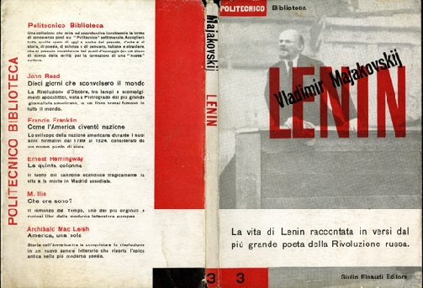

**Figure 3:1964, example of Steiner's graphics for the covers of the "Politecnico Biblioteca" book series. Source:** http://www.oblique.it/manifesto_steiner.html



**Figure 4: example of the style change made by Munari in 1965**

Another profound change was the graphical design of the series "Piccola Biblioteca Einaudi".

The cover of this series is a symbol of the graphics of the publishing house. In it appears the "cage" of squares inscribed in the rectangular format of the book, which still today represent the symbolic element of many Einaudi collections (see Figure 5).

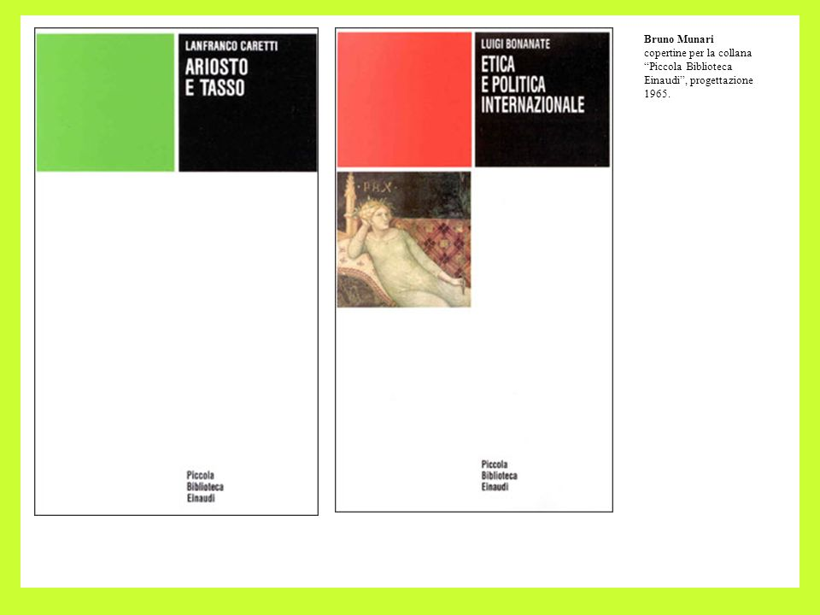

**Figure 5: examples of the graphics introduced by Munari for the series "Piccola Biblioteca Einaudi". Source:** <https://slideplayer.it/slide/581324/>

**3.1.2.3 The "Millenni" and the red frames**

The "Millenni" host classics that want to be proposed to current literature.

It is a book series, of classics of all times, from Latin and Greek literature, to that of the Middle Ages and humanism, to the great novels of the origins of the modern age.

The first graphic design included a simple and essential cover. White cover with only three additional elements: title, author and the Einaudi logo. This choice comes from the fact of wanting to show the classicism of the works collected within the series (see Figure 6).

Over the years the graphic department decided to follow the guidelines set for other series by Bruno Munari trying to keep the essential and classic look, for this reason, the cover had experienced a significant change: they introduce author's illustrations framed in a square bordered with red. The red frame has the task of directing the eye towards what it contains (see Figure 7).



**Figure 6, 7: on the left volume of the series the "Millenni" of 1954, on the right instead the revisited edition in 1984**

**Source 6: MareMagnum**

**3.1.2.4 The colour illustrations of "Nuovi Coralli" and "Supercoralli" book series**

"Nuovi Coralli" and "Supercoralli" are since 1948 a great series of literature, with novels and short stories of the twentieth century. The great novelty introduced by Max Huber is the use of colour illustrations that correspond to the spirit of the book. Originally, the images were stacked on the covers with time were directly printed on them (see Figure 8, 9).

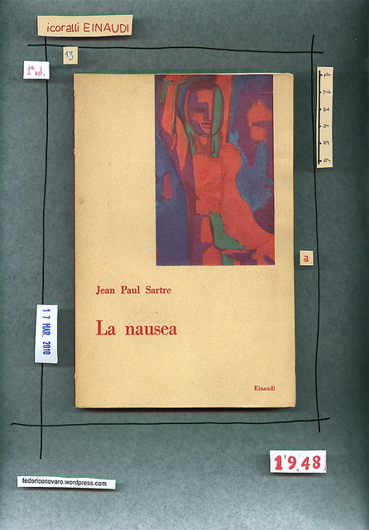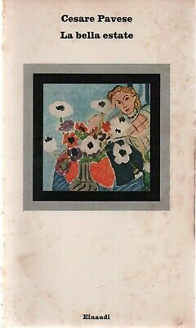

**Figure 8, 9: on the left graphic of the series the “Nuovi Coralli” of 1948, on the right instead the renovation of 1971**

**Source 8:** <https://federiconovaro.wordpress.com/2011/03/18/jean-paul-sartre-la-nausea-einaudi-1948-copertina-i-coralli-einaudi/>

**Source 9: ibs**

**3.1.2.5 Innovations in "Gli struzzi" book series**

The series "Gli Struzzi", born in 1970, collects inexpensive reprints of works from other series that were successful with readers. It addresses a wide audience to propose essential books: from the classics to fiction, poetry and contemporary theatre. The graphic design of the series is influenced by the use of Huber's colour images. But from the very first covers, a great novelty appears: the logo of the publishing house is no longer at the bottom but at the top right, as if to direct the observer's attention to the other elements of the cover (see Figure 10).

Even the lettering of the title and the author's name changed both are made with the same character and the same body as if they were part of a continuous text where there are no priorities.

Over the years the graphics are modified until the current cover, which is very similar to the past ones. The only differences are the integration of the text and the image and the use of less regular lettering (see Figure 11, 12, 13).



**Figure 10, 11: on the left example of the book of the series "Gli struzzi" of 1975, on the right 1984. Source 10: Abebook. Source 11: Mondadori store**



**Figure 12, 13: on the left example of the book of the series "Gli struzzi" of 1997, on the right 2006**

**3.1.2.6 Pocket Einaudi. The restyling**

Born in 1989 by Oreste del Buono, in 1992 it was redesigned and divided into three different sections: Literature, Essays, Classics. Subsequently it was enriched with the series Bilingual, Writers translated by writers, Poetry and Large Pocketbooks.

The initial graphic image did not include the classic white cover, but were covers in soft colours with a white part in the centre where were placed the title, the author, the logo and a colour image in reference to the content of the book (see Figure 14).

In the first Restyling the covers with soft colours are replaced by the classic white one, with lettering of characters and bodies less tough than in the past. The graphic style is aligned with the style of the “Nuovi coralli" series (see Figure 15).

The most significant change occurred in particular in 2005, when the new ET (Einaudi Tascabili) brand was born. The series diversified in its graphic design (see Figure 16).

Next to this new brand is introduced the new "Struzzo Einaudi" designed by Picasso in 1951.

The great restyling brings the use of images that fill the entire cover space integrating with the lettering of the titles and names of the authors that become a part of the cover images.

Despite the considerable change some sections like "ET Poetry" and "ET Theatre" have kept some clear references to the past. In "ET Poetry" is still present on the cover the original text (See Figure 17, 18).

 

**Figure 14, 15: on the left example of a cover with the first graphic of 1990, on the right the paperbacks in the new look of 1995**



**Figure 16: example of a cover of ET (Einaudi tascabili) born in 2005**



**Figure 17, 18: example of how the graphics of the covers of the poetic texts remained unmodified. On the left cover of the 1965 on the right of 2019**

**3.1.2.7 The Einaudi graphics today**

Currently, the graphic research of the publishing house focuses on the series born in 1996: "Stile Libero”, a series of the avant-garde, and at the same time well inserted in the market, in which two fundamental criteria for Einaudi are followed: experimentalism and the mixing of genres and languages. Its graphic design collects the spirit of a style directed to young people and not only, able to capture the attention of the reader.

The cover graphics gradually move away from Einaudi's white cover, using full-page illustrations more and more frequently.

The image of this book series is a look to the future. Despite the changes has been tried to remain in line with the Einaudiana tradition. An example is the first covers designed in 1996, which still preserve the white cover combined with colour images (see Figure 19). The major feature that links the images in today's covers and those of the past, is the careful research with which they were chosen. The common thread is the non-violent use of the images, placed on the cover not as purely spatial or decorative elements but as symbolic references to the contents of the book (see Figure 20).

 

**Figure 19, 20: on the left "Stile libero" collection cover of 1998 on the right of 2020**

## **3.2 Adelphi**

Adelphi books are immediately recognizable from their covers: from the pastel colours to the opaque paper used, up to the images chosen according to the reverse ecphrase (ecfrasi) procedure, trying to find the equivalent or analogous of a text in a single image.

Since its foundation, Adelphi has been able to introduce names that are sometimes unfamiliar on the world panorama but then proved to be of influence on contemporary culture.

From the very beginning, Adelphi's need was to restart from a focus on the classics; a different point of view respect that expressed by Italian idealist, Marxist and Catholic culture. The idea was not overloaded the texts with commentaries or introductions, but without renouncing philological rigour; another intention was to include not only works of philosophy, but also science and religion, drawing on Eastern traditions, Buddhism and Islamism (Belpoliti 2018).

### **3.2.1 The Adelphi history**

**3.2.1.1 The sixties**

Adelphi was founded in 1962 by the literary critic Luciano Foà (from the Einaudi galaxy), together with Roberto Olivetti, Giorgio Colli. One of the first young collaborators was Roberto Calasso, who became its editorial director in 1971. However, at the origins of Adelphi, there is the human and intellectual connection between Luciano Foà and Roberto Bazlen, who played a fundamental role in the Milanese publishing house, which helped to define Adelphi's identity and to develop an original and unique editorial line in the Italian scenario (Vitalba Giudice 2020).

Bazlen's main idea was to publish all those books he had discovered for years but which he had never managed to publish in the various Italian publishers he had worked with, from Bompiani to Einaudi.

For him, Adelphi was the publishing house of the "libri unici" (unique books): those where it was immediately recognized that something happened to the author.

In the beginning, there was only reference to "libri unici" because Adelphi had not yet found his name. There were only a few certain facts: the critical edition of Nietzsche, which alone was enough to guide everything else. And then there was a series of Classics, based on the criteria of doing well what had previously been done less well and doing for the first time what had previously been ignored (Calasso 2013, 13).

The symbol of the publishing house was recommended by a young friend: Claudio Rugafiori. The meaning is simple: new moon, death and resurrection. The name comes later. It is at the home of Roberto Olivetti, the investor, in a meeting between friends, that Luciano Foà brings a list of names. Although Foà was in favour of other names, that evening the name was chosen was Adelphi. Adelphi means several things, reminds Calasso; in Greek, it is "brothers", but it is also used in English theatres and clubs, and even in literary magazines (Belpoliti 2018).

In 1963, the first collection of "Classici" was introduced: a series accompanied by a refined critical analysis, which was written with great editorial care, and which will characterize the following production (Ferretti 2004, 197). But the innovative character of Adelphi became evident only in the subsequent years.

In 1964 the "Saggi" series was born, and in 1965 the "Biblioteca Adelphi" series was inaugurated, replacing the "Classici" in the role of the House's leading series (Ferretti 2004, 198).

Its graphic layout is simple and, as the flap says: "A series of unique books chosen according to a single criterion: the depth of the experience from which they are born and of which they are testimony. Books of today and yesterday, novels, essays, autobiographies, plays, experiences of reality or imagination, of the world of affection and thought" (Vitalba Giudice 2020).

From the beginning, one of the ingredients capable of making Adelphi books immediately recognizable is their graphic appearance, which has evolved over the decades but without compromising the key principles of the publishing house.

Once they chose the name of the “Biblioteca Adelphi” series, they had to take care of the graphic aspect. They agreed to avoid white and graphics designers. White because it was the strong point of Einaudi graphics, the most beautiful in circulation during that period. So they decided to focus on colour and opaque paper. As for colours, those in use at that time in Italian publishing were rather few and quite brutal. Remained to be explored various ranges of intermediate tones (Calasso 2013, 19). The graphic design was commissioned to Enzo Mari, but it was Michele Ranchetti, who suggested using a graphic scheme by Aubrey Beardsley, 19th-century English engraver and illustrator, for the covers of the books of the " Biblioteca Adelphi" (Belpoliti 2018). With a few small variations, replacing the inscription “Biblioteca Adelphi” with the frieze that Beardsley inserted on the black upper strip, the cover was already made and, in particular, a frame was provided to introduce an element they considered essential: the image (Calasso 2013, 19) (see Figure 21, 22).

Concerning the image on the cover, was considered by Calasso the reverse side of the ecphrase: the translation of the text itself into an image (Calasso 2013, 20).

The image must be perceived as in line with the text by multiple foreign eyes. The intent was to offer an image that intrigues and attracts an unknown person to pick up an object of which he knows nothing except the name of the author, the title, the publisher's name and the flap. But at the same time, the image of the cover must be right even after reading the book (Calasso 2013, 21).

Therefore, for more than thirty years, Foà and Calasso have evaluated, testing and retrying, hundreds and hundreds of images, formats, background colours (Calasso 2013, 23).

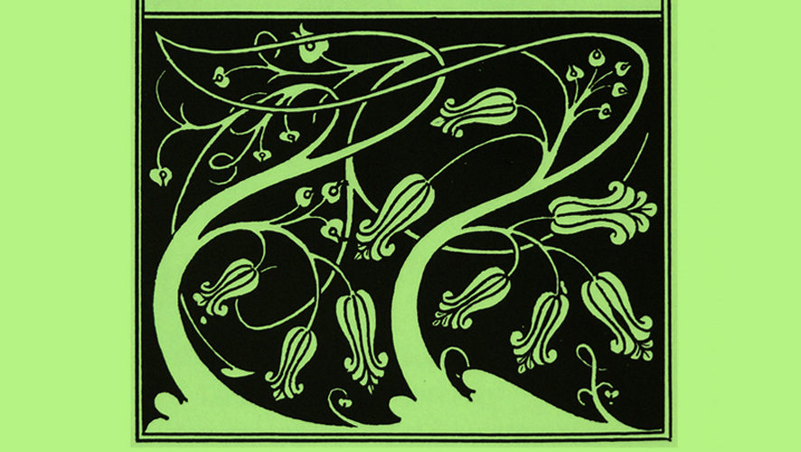

**Figure 21: Illustration by Aubrey Beardsley used by Adelphi for "Padre e figlio" by Edmund Gosse (1965). Source:** <http://notizie.dimanoinmano.it/2020/02/19/case-editrici-italiane-adelphi/>

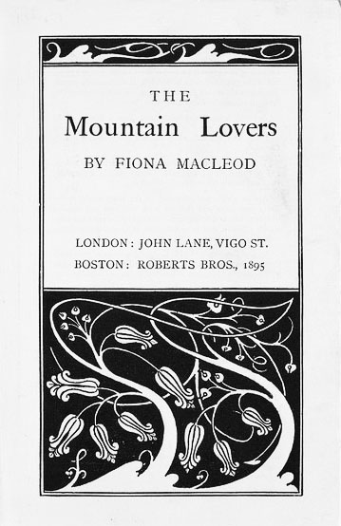

**Figure 22: example of Beardsley cover graphics subsequently modified by Einaudi. Source:** <http://poulwebb.blogspot.com/2013/03/aubrey-beardsley-part-4.html>

In 1965, shortly after the start of Adelphi's activity, Bobi Bazlen died. Bazlen was the engine of the publishing house. However, he left a heritage of editorial files and above all, letters addressed to Luciano Foà, containing titles to be published, indications on translators and collaborators, which inevitably ended up feeding the publishing house's production in the following decade.

In the early days, the entire group of Adelphi, in which Roberto Calasso became more and more important, realized Bazlen's program, but then it was Calasso himself, very active in suggesting books, to impose himself as the main consultant, decisive in editorial choices. In 1968, when he moved to Milan, his role as publishing director was also officially confirmed (Belpoliti 2018).

The Library's fortunes began to clear up when a certain number of readers discovered, book after book, that that constellation was being drawn, without preclusions of genres (Calasso 2013, 30).

**3.2.1.2 The seventies**

The real period of expansion for Adelphi arrives in 1971: thanks to a new company structure, the publishing house can finally count on solid budget and thus expand its production, which goes from about ten annual titles in the sixties to almost forty in the seventies (Vitalba Giudice 2020).

**3.2.1.3 The eighties**

From 1989 onwards, it duplicates the titles produced annually, also thanks to the success of the Adelphi Pocketbook series. As the journalist Gian Carlo Ferretti suggests, the success of the Adelphi publishing house is to be found in its "ability to maintain an image that is consistent with its publishing history, even though the changes of the different eras, and to become the new archetype of the book of culture in the imagination of the cultured reader: cultural and customs phenomena together” (Vitalba Giudice 2020).

### **3.2.2 The Adelphi graphic design**

In the following pages the graphic design evolution of some of the most famous series of the publishing house will be analysed to underline the changes made to maintain the continuity with the times but at the same time the desire to remain in line with a precise style that expresses the philosophy of the publishing house supported by the care and attention to quality in the choices made for the realization of the covers.

In 1965, the internal graphics department, led by Cappelletti, and the group of the publishing house decided the image strategy that makes Adelphi a case in the Italian and international publishing scene. The first strong sign is the logo: a symbol traced with the great tradition of pictographic writing in mind. This sign, with an oriental flavour, is placed in the context of the frame of the cover; beardsleyana, the frame contains, in the main collections, the epigraphic inscription that represents the series such as “Biblioteca Adelphi” or “Piccola Biblioteca” etc., stamped in negative. Another masterly touch are the pastel shades that still show the intensity of their delicacy, confirming the successful choice made.

**3.2.2.1 The “Classici” Adelphi**

The "Classici" is one of the principal book series of the publisher, and it was the first series released in 1963.

The initial graphic design had white covers in which was reported, aligned to the left, author, title, and Adelphi coloured logo and eventually in the lower part of the cover information about the preface, the notes or any appendices (see Figure 23).

The graphics of this series remained almost untouched over the years. An addition that has been made in more recent years is a coloured label, in contrast with the white cover, which contains information to capture the attention of the possible reader (see Figure 24).

 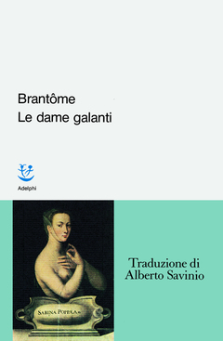

**Figure 23, 24: on the left 1963 cover example, on the right example of a paper band added to the covers of the "Classici"**

In 1984 for the works divided into several volumes, boxes are created, in which the cover of the box itself is more decorated: in some cases, it presents the photo of the author and in other reproduction of artwork (see Figure 25). The book inside, however, keeps the classic white and linear cover.



**Figure 25: example of a 1984 box case**

**3.2.2.2 The “Saggi” and their radical transfomation**

In 1964 was born the series "Saggi" that has a different graphic look than the "Classici" the cover has horizontal coloured rows of various sizes on a white background.

But it continues to have some features of the "Classici" regarding the font used and the arrangement of the information that is always placed on the left side of the cover (see Figure 26).

A few years later, in 1967, the graphic design was changed it was closer to the style of the series the “Classici": white cover with author and title aligned on the left and coloured Adelphi logo. The main difference with respect the “Classici” is the choice to augment the body of the title, which in this case is in italics, and more distanced from the author's name (see Figure 27).



**Figure 26, 27: on the left 1965 example of cover of the " Saggi", on the right example of the 1967**

In 1974 a further change was made, presumably deriving from the need to harmonize this series with the style that most identified the publishing house with that of the " Biblioteca Adelphi": a cover made of opaque paper with a frame that identifies the section in which the author, title and logo are inserted (see Figure 28). Unlike the covers of the " Biblioteca Adelphi", there is no images representative of the text and the title and author are in the upper right corner in large and legible font in black or white, depending on the rendering concerning the colour of the cover. Initially, regarding the arrangement of the author's name and font size, there was no single line because in some cases it was possible to find it at the top right, in an italic and smaller size, separated from the title, while in other texts, it was chosen to place it just above the title and of equal size. Starting from 1983 it was decided to follow the first layout, common to all the texts (see Figure 29).



**Figure 28, 29: on the left example of cover of 1974 on the right of 1981**

Since 1990, the essays published by the publishing house were included in a new collection called "I Saggi. Nuova serie".

A constant is a coloured cover, with the author, title and logo aligned in the centre, as was done for the covers of the " Biblioteca Adelphi". The peculiarity of this series is the frame of the cover that for each book is different, and it reproduced a pattern that can be traced back to paintings, architectural motifs, ancient wallpapers, miniatures of medieval codices that existed. This choice is the example of the study carried out for the realization of every single cover that assumes a character of uniqueness and at the same time of belonging to the series itself (see Figure 30).

In particular cases since 1998, some texts were enriched by an overlay, which protected the classic cover previously described. In some cases, the overcover showed a work of art or, more often, the portrait of the author (see Figure 31).



**Figure 30, 31: on the left 2001 example of cover where the cover border is taken from the decoration of a medieval code, on the right example of an overcover created in 2016**

**3.2.2.3 “Biblioteca Adelphi” and the birth of the most famous Adelphi graphic design**

The "Biblioteca Adelphi", one of the main series, was founded in 1965 with the release of "L'altra parte" by Alfred Kubin. The series was born from Bazlen's choices: preference for fantastic themes of literature, co-presence of different literary genres and convergence of literature and nonfiction (Ferretti, Iannuzzi 2014, 220).

With an average of one title per month, it has published over 700 volumes of various kinds. With this series, Adelphi was able to introduce little-known names in the world scene, which then revealed to be of influence on contemporary culture.

The books in the collection are distinguished by their appearance. They are presented with an opaque paper cover with colours that explore the various ranges of intermediate tones; the inscription “Biblioteca Adelphi” and book enumeration is placed on a black upper strip and below it, there is a frame that introduces the name of the author, the title and an essential element: the image, the equivalent of the text in a single figure.

The author's name and surname are indicated in italics and precede the title, only in a minority of cases they follow it. Regarding the title, there is not a single guideline because in some cases it is written in lower case while in others in upper case.

The graphic design is far from being current and showy. For the illustrations, there is a preference for not, particularly known authors.

The changes that can be noticed in some covers are rarely permanent for all subsequent texts since in most cases they are adjustments made to the traditional layout to insert images of artworks that do not have a standard shape. Despite this, the basic structure and layout chosen for the covers of the first published texts will continue to be used in the following years. Alternated with some more innovative and particular covers.

With the passing of the years and the publication of new editions of the texts, some covers have been modified to give a more contemporary look to the books and attract the attention of new readers.

In 1968, for the first time in the series, a photograph was included on the cover. In these years it is possible to see the inclusion of the first coloured paintings and in some cases, it increases the space destined to the image, which is more central and no longer enclosed within the black frame that delimits the space reserved for it (see Figure 32, 33).

Another sporadic change appeared in 1972 when the title was written in red instead of classic black (see Figure 34).



**Figure 32, 33: example of covers of 1968**



**Figure 34: 1972, example of cover**

**3.2.2.4 Examples of unique covers of “Biblioteca Adelphi”**

In 1976 for the first time, the chosen work of art seems to be in movement in the cover it does not remain enclosed in the square usually dedicated to images (see Figure 35).

In 1990 an extremely personalized cover was created for the author Sto because for the first time a different font from the classic one was used for the title and the author name (see Figure 36).

Since 2007 the first covers begin to appear where there are images that fill the entire background, always leaving visible the colour of the cover (see Figure 37).

In 2019 for the first time, was created a cover in which the title and the author are placed at the bottom, it gave more importance to the image (see Figure 38).

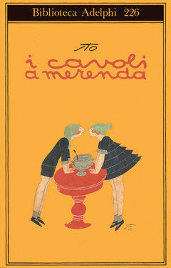

**Figure 35, 36: on the left 1976 cover example on the right 1900 cover example**

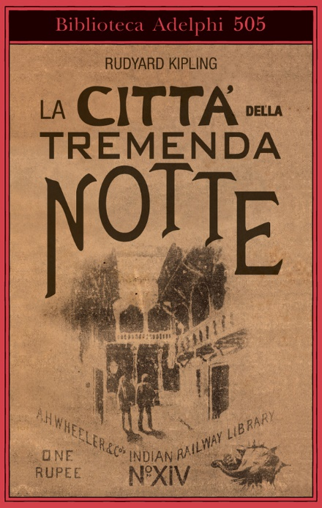

**Figure 37, 38: on the left 2007 cover example on the right, 2019 cover example**

## **3.3 Conclusions on the analysis of the graphic design of Einaudi and Adelphi**

Analysing the evolution of two fundamental publishing houses for the Italian publishing industry, it emerged that Einaudi was a true pioneer in the field of editorial graphics. He realized that the cover is more than anything else an invitation to enter into the book, a mirror for the reader, a way to get in touch with the public (Colombo 2013).

He also revealed the importance of reflecting on Italian society, the needs of the reader and the principles of visual communication, graphics and design.

The main characteristics of the Einaudi publishing house are essentiality and refinement. The same that are expressed in the other paratextual elements: indexes, biographies, title page. The white Einaudi is a symbol of cleanliness, simplicity and refinement and never has an aniconic character: it does not reject images, on the contrary, it wants to enhance them by choosing those that can best bring out the spirit of the book and placing them in a distinctive position, according to the book series or its characteristics.

Einaudi covers remain a clear reference point of classic elegance; from the Coralli series in all its declinations to Einaudi stile libero. They are all characterized by a careful and sober search for a refined layout and image.

About the Adelphi publishing house, a key fact appears: the origin, the history, the identity of Adelphi is determined, also, by opposition to an antagonist; Adelphi is the anti-Einaudi. the characteristics of the two publishing houses are opposite: rational vs. irrational; white vs. colour; pedagogical tension vs. pleasure as the ultimate goal (Bricchi 2013).

With the publication of the "libro unico" (unique books) and for the graphic design visible from the unique coloured and opaque covers, Adelphi chose the opposite of what the different cultures of the time demanded. The books in the Adelphi catalogue are both solitary and social, unique and at the same time part of a network. Therefore, the books, are both untied and dependent (Bricchi 2013).

Despite the differences that have emerged between the two publishing houses: for both is evident the constant search for a code that allows, on the one hand, to attract, to bring closer, on the other hand, to find a coordinated image of impact, effect, recognizable, which is in line with the text and the publishing house itself (Colombo 2013).

## **3.4 Different graphic choices between non-fiction and narrative**

After having analysed the graphic design of two publishing houses known especially for narrative texts, it is advisable to consider the panorama of non-fiction to emphasize the differences that lie in the creation of covers dedicated to fiction and essays.

I have taken as a reference to the series of non-fiction of il Mulino, Bolognese publishing house.

The publications of il Mulino include an extensive catalogue of magazines and a rich production of books with a differentiated profile. A section of the publishing programs is dedicated to reference and research texts, aimed in particular at the community of scholars. Another important editorial director is identified in the instrumental volumes, intended for study and university teaching. Moreover, in the last few years, the series addressed to the non-specialized public have been particularly developed, through which the most innovative and current cultural researches and acquisitions are directed to the public discussion, and which have contributed to pointing out the il Mulino as one of the most active publishers of culture in our country.

**3.4.1 History of the publishing house “il Mulino”[3]**

The publishing house il Mulino was founded in June 1954, following the initiative of the group that three years earlier, in April 1951, had created the magazine "il Mulino", intending to extend the group's presence in the Italian cultural and political world.

The nature of the production was clear, characterized by Italian and foreign research publications, which were later followed by analytical texts of synthesis and orientation. Texts on history, philosophy, literary criticism, sociology and politics were published, with a marked involvement in the fields of sociology and politics, which ended up characterizing in a particular way the profile of the publisher.

Starting from 1964, the publishing house began to expand in two directions: on the one hand, the publication of the magazine "il Mulino" was combined with the publication of other magazines; on the other hand, new series were set up, focusing in particular on the publication of texts, which could be used in the university and, later, with the creation of the "Universale paperbacks" in 1974, on the low price book market.

With the passing of the years, the political and cultural line of the publisher has expanded to new disciplinary areas and more precise articulation of production in the different series.

Today the publishing company produces magazines and books on history, philosophy, linguistics, literary criticism, demography, anthropology, psychology, sociology, political science, economics and law. The series have been enriched in particular in the direction of non-specialist texts, which have developed the publisher's presence in the Italian publishing market.

In this context is placed the digital proposal launched in recent years. Rivisteweb, the magazine archives, Darwinbooks, the collection of research texts, ebooks represent the effort to enhance the publisher's production in new forms and through new channels.

### **3.4.2 Graphic evolution of the series "Saggi" Il Mulino**

Similar to the publishing houses that deal with fiction, also in this case the editorial graphics have evolved.

In 1995 the first texts of the series were published.

The first graphic layout, which will be maintained only until 1996, is formed by a coloured box where the title was placed in the centre, it was written in a common and linear font. Around this section, there is a frame of a darker shade, compared to the central one, at the top is indicated the name of the author and at the bottom of the publisher. In 1996 some texts were enriched with drawings that recall the title of the text (see Figure 39, 40).



**Figure 39, 40: 1996 cover example. Source: ibs**

Since 1997 there has been a change in the graphic design, which however remains basic and without excessive decoration.

The covers were made in soft colours: light blue, green, purple, yellow and it was divided into two sections of the same shade, differing in colour intensity, in fact, the first section, the darker and smaller one, contains only the name of the author; the second larger section contains the title and at the bottom left the name of the publishing house with the indication of the series. The fonts chosen are classic and with a visible body (see Figure 41).

This graphic design will remain untouched until 2002 when for the first time on some titles of the series will be included, in the central part of the cover, drawings or photographs related to the subject, it was modified to reflect the colours chosen for the cover (see Figure 42, 43).



**Figure 41: 1998 cover example**



**Figure 42, 43: on the left example of 2002 cover, on the right of 2003**

After several years in which there was an alternation of decorated and classic covers since 2007 on all published texts were included images and drawings always ton sur ton according to the colour chosen for the covers.

In the same year, a new graphic began to appear: the first covers with a white background, in which the author and the title are enclosed in a coloured box placed at the top. In this case, the photos and drawings maintain the original colours and are highlighted by the white background (see Figure 44, 45).

The graphic design described above remains the same until today, but in occasional cases, completely different covers from the style used by the publishing house were created. These present images and titles that merge occupying all the space of the cover (see Figure 46, 47).

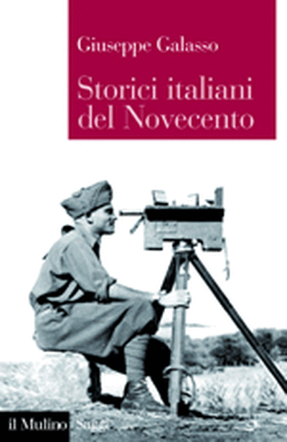

**Figure 44, 45: examples of 2008 covers**



**Figure 46, 47:** **from left cover example of 2011, to the right of 2019**

### **3.4.3 Covers comparison**



**Figure 48: from left cover example: Il Mulino, Adelphi and Einaudi**

Although all three covers contain the same elements: author, title, publisher's name, and an image, the final result and the impression the reader derives from it, is completely different due to the choices made about the font, the layout and the colour combination.

In the case of il Mulino, the purpose of the images on the cover is to visually identify the title, not to draw an atmosphere and bring to mind the story that surrounds it, as it is perceived more for the Adelphi and Einaudi covers.

Adelphi and Einaudi, unlike il Mulino, try to have a much stronger identity and for this reason, over the years they have created a graphic design able to emphasize and strengthen it, they are graphic projects that never grow old, they contribute to reinforce the value of the content, to create an aura that a book gives off just for the fact of being "dressed" in a certain way (Falcinelli 2011, 138).

For the covers of Adelphi and Einaudi, the image is also framed. It is a solution that allows an effective balance between the identity of the book and of the producer who proposes it to the public. The image identifies the individual work but is accompanied by recognizable graphic elements that indicate the publisher or the series. For example, for Adelphi, a real decorative frame has been created, with personalized shape, colour and proportions to ensure the identification of the publisher and, within its production, of the individual series. On the other hand, in the case of il Mulino, the graphic design chosen is not focused purely on allowing the reader to immediately recognize the publisher and the belonging of the text to a specific series.

What it is missing in the covers of il Mulino, which instead is strongly present in Adelphi's covers, is the emphasis on seriality with the intent to stimulate the reader to follow the House with constancy from one publication to another, but this is understandable considering the different themes dealt with in the essays.

Despite the differences found, the intention of these publishing houses is to keep the covers as minimal and clean as possible but at the same time to attract the reader's attention. These are proof of how few elements are needed to create outstanding covers.

# **4. CssLibrary**

In the previous chapters, I have analysed from a historical point of view the evolution of covers, which were born as a protective instrument of the text until they became a vehicle through which books promote themselves. In particular, I analysed the changes in the graphic layout of three Italian publishing houses: Adelphi, Einaudi and Il Mulino, and the differences between the covers of non-fiction narrative texts. These studies have emphasised the increasingly important role of covers, especially in the digital world where they become the only tool to attract the reader's attention.

## **4.1 Birth of the CSS Library**

The growing need to publish texts in different formats and readable on different devices for example eReaders or mobile phones has led me to consider the practice of publishing graphics and to find a method through which, quickly and immediately, it is possible to design covers and adapt them to different sizes. For this reason, I created a CSS library to meet the purpose I had planned.

At the moment, in addition to the graphics programs used by expert designers, it is possible to create covers through sites or applications like Canvas or Adobe Spark, which provide templates that facilitate the creation but, on the other hand, have some features that allow an expert eye to identify their origin.

As mentioned before, what I wanted to create is a CSS library, which allows creating very different covers through the use of three files. The HTML file that contains all the essential data that must be shown on the cover, to this file it is possible to link the CSS style sheets included in the library: the one that the designer does not need to modify and that contains all those properties that must remain unchanged regardless of the style of the cover, in particular, refers to the formats currently most exploited for the publication of books both in the digital and analogue world. Furthermore, there is the CSS file that designers can modify according to the designer's needs and the style they want to assign to the cover.

The choice to use HTML and CSS comes from the fact that together with XML are the formats usually adopted for the production of eBooks. For this reason, it might be more convenient to include this type of file for the production of covers, to limit the number of different formats used and to increase homogeneity.

The library I have created can be found at the following link, where I have inserted all the files it contains and examples of how it works: <https://saraarmaroli.github.io/>

### **4.1.1 Files in the Library**

This library is composed of three different files:

* HTML files
* CSS file containing properties that must remain unchanged independent of cover style
* CSS files that the graphic designer can modify to achieve the expected result

For the creation of the HTML file, as I will explain later, I took as reference "I promessi sposi" of Alessandro Manzoni. The file includes all the elements that can be displayed on the cover of the text. The classes selected include both those that allow identifying the most common information present in all the editions as title, author and publishing house and classes that could represent further details present in some editions such as the editor or the presence of an introduction.

The choice of which elements to display is obviously in the hands of the designer who can choose which ones to display.

To facilitate the creation of the cover, from a graphic and visual point of view, in addition to the DIV where the logo can be placed, additional spaces have been added to allow the designer to include an image and decorations that could be used to enrich the cover.

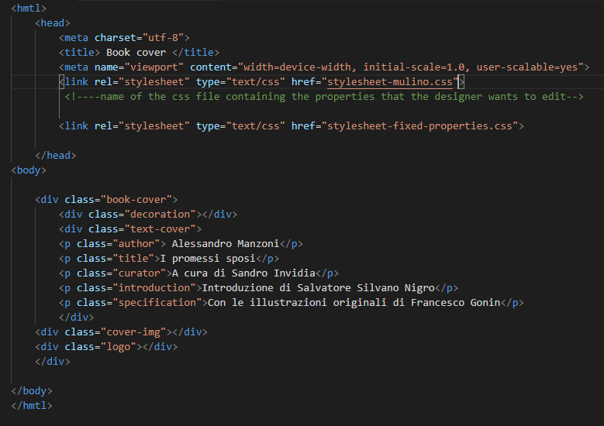

From the header of this HTML file, it is possible to notice that two different style sheets have been linked. The first refers to the one containing the properties editable by the designer, while the second ("stylesheet-fixed-properties") concerns properties that can remain unchanged.

The second file includes all the properties that need to remain fixed, from my point of view, and which the designer does not need to modify to achieve good results in the creation of the covers.

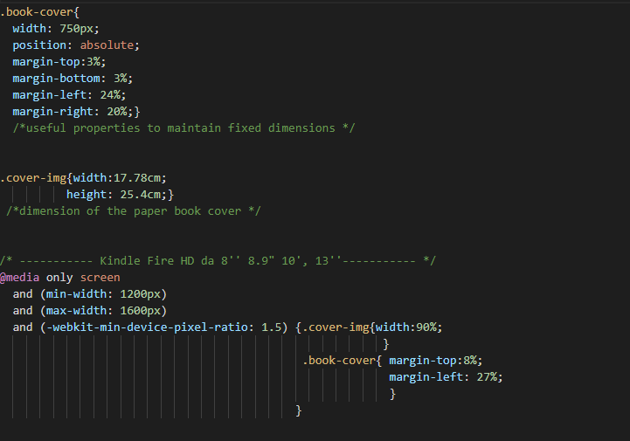

From the first classes, the first properties that I considered fundamental to establish and that can be kept unchanged are related to the dimensions that the cover and the image inside it must have.

In particular, the values I have assigned to the "book-cover" class, that is the representative class of the cover and the one containing all the other classes, allow the cover to be displayed in the centre of a computer screen. Furthermore, with the property "position: absolute" and "width" in pixels, I have intentionally established that the size and arrangement of the elements should not be altered when the screen is reduced and therefore the relationship between the elements inside it should remain intact.

Exploiting this property, the ratio between the elements displayed on devices of different sizes remains unchanged. Besides, the values that must be taken into account in media queries related to various devices refer to minor details that must be adjusted to obtain a result appropriate to the size of the device, for example, margins, or the size of images or fonts.

The cover image class, on the other hand, is the space I assigned to the image that the designer may decide to insert. In addition to this function, I have assigned the class the size that the cover must have.

Although I am aware that centimetres are an outdated unit of measurement and not recommended when talking about the web, I decided to indicate the initial dimension of the cover using this measurement unit because it is representative of the size that the cover in the analogue format must have. I chose these sizes because I preferred to consider a larger format than traditional novels to make it easier to read since it is a consistent text enriched with notes and comments.

Subsequently, the measures adopted for the image, referring to covers suitable for digital devices, will be in percentage and no longer in centimetres since I am referring to digital content.

After choosing the size for the cover in analogue format and how to display it on a computer screen, I focused on media query analysis. This was a fundamental step because through them I outlined the type of device on which to display the covers in the best way.

For the realization of this style sheet, I carried out a detailed analysis to understand what were the size ranges of the devices to be considered to be able to include all those that I had planned to reach, in particular: smartphones, tablets, digital readers and traditional covers, as well as the possibility of an adequate display even on large screens- The latter mode is useful not only for a possible reader but also for those who are dedicated to the creation of the cover itself.

For example, I have considered digital reading devices, Kindle and others, with screens from 6 inches up to 13 inches, as well as large mobile phones or 12.9-inch tablets. As can be noticed from the comments on the CSS file, I didn't create specific media queries concerning the single category (only eReader, or smartphone) because in some cases tablets and digital reading devices have screens of the same size and resolution and for this reason, I grouped them in single media queries.

In the media queries of this first CSS file, as previously mentioned, I referred to properties concerning the size of the images and the positioning of the cover inside the viewport, since they are the ones that share all possible styles and facilitate a correct display on different devices. Moreover, I decided not to differentiate the rendering and graphics of the cover between one device and another because, also following the analysis made in the previous chapters, I believe it is fundamental that there are no differences between the covers displayed on different media in order not to create confusion for a possible consumer and therefore make the cover easily recognizable and memorable.

Naturally, if a graphic designer decides to create a different look for covers in digital format compared to paper, he/she can do it by applying changes in the CSS file dedicated to him/her.

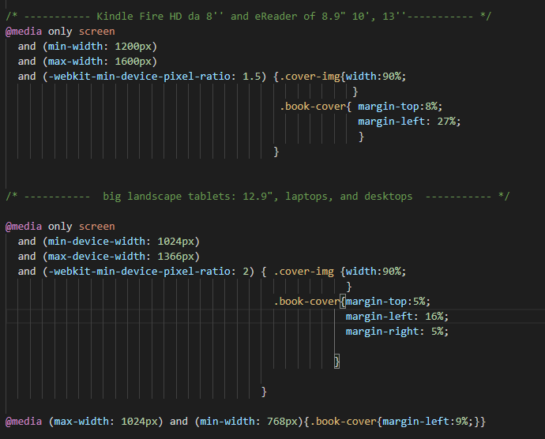

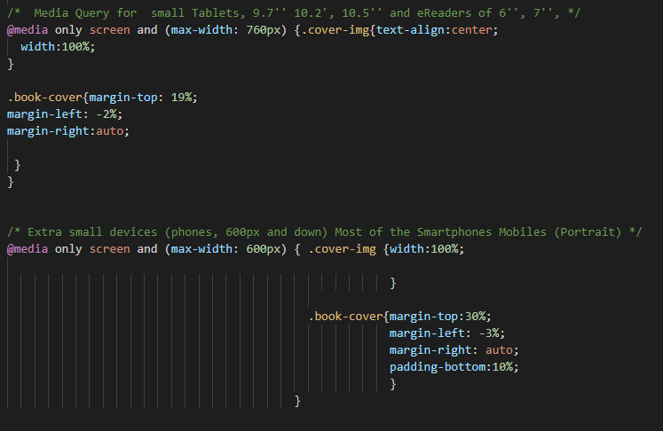

When these properties are established, the designer has the basic structure to proceed with the customization of the covers.

To show how the library works, I have also created the third and last file needed to complete the covers, which is the one the designer can edit to create the graphic design he/she likes.

Following is one of the CSS files that I designed to create the cover of the "Promessi sposi" exploiting the style of the non-fiction text used by the publishing house il Mulino. This example shows the work that an editorial graphic designer should do to create a cover using the library that I created.

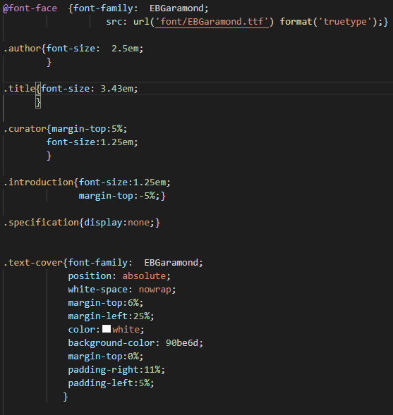

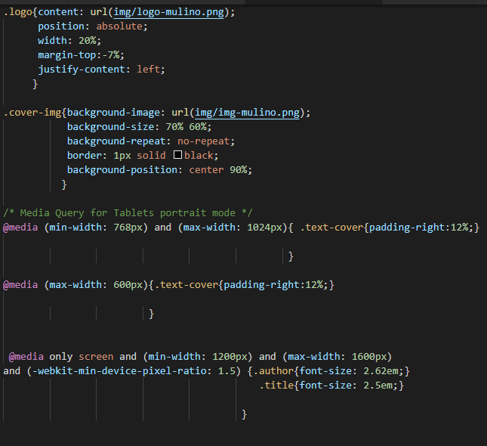

The work that has to be done, having the previous two files available, is particularly related to personalisation, therefore the choice of font, colours, images and the insertion of the publisher's logo and the positioning of the elements on the cover. Also in this file, there are some media queries that in this case refer to properties related to the classes to which only the designer refers and that he/she wants to display differently in particular devices.

Below the result obtained by exploiting the three files described below, where the modifications for the reproduction of the graphics of the publishing house il Mulino were made only in the second CSS file, leaving the other two unchanged.



## **4.2 Use of the CSS Library**

To test and show how the CSS library works and to underline that starting from the same HTML file, modulating some parameters of a single CSS sheet, it was possible to recreate very different covers in different formats in a short time: I decided to use it in three different ways: reproducing covers already on the market, creating new ones inspired by the styles of well-known publishing houses and designing a completely new cover.

For all three uses, I decided to refer to the text of the Promessi sposi by Alessandro Manzoni. Furthermore, for all the examples it is possible to find the CSS files related to each edition on the library's website: <https://saraarmaroli.github.io/>.

The choice fell on Promessi sposi, being a text studied with great attention in high school and a milestone in Italian literature, as well as the artwork with which Manzoni introduced the genre of the novel in ItalyAnother reason that encouraged me to dedicate to the creation of the cover of this text is the observation of what is currently on the market, which is mostly school editions that do not promote reading but underline the fact that they are texts intended for the school environment. To illustrate better that impression, I attached some examples of the covers currently on the market, some of them do not fall into the "category" of educational covers and have inspired me to proceed with their reproduction and this is the case of Feltrinelli and Mondadori.



**Fig: on the left Mondadori cover, on the right Feltrinelli Universale a colori**



**Fig: on the left Einaudi, on the right new Zanichelli edition for the school**



**Fig: on the left Loescher, on the right Garzanti**

### **4.2.1 Reproduction of existing covers**

One of the ways I used to test the CCS Library was to reproduce covers of existing editions of "I Promessi sposi", in particular I chose to experiment with that of Feltrinelli, Mondadori and the school edition of Zanichelli.

**4.2.1.1 Feltrinelli**

Regarding the cover of Feltrinelli, I reproduced the edition of 2014. Placing the original and the recreated version one next to the other makes it possible to notice the presence of some differences in particular concerning those elements as the image and logo that I could not create directly on the CSS file.

In fact, for the main image, I contoured and cut the original one on the cover using Gimp, and to obtain an image that wasn't jagged, I had to make some changes to the original design that led to some differences. Another discrepancy, as mentioned above, is the clarity and size of the publisher's logo which I had to cut out from the original text because I wanted it to be the exact colour but this affected the quality.

I am satisfied with the choice of the font used (OpenSans-Regular) and the decoration on the top of the cover, for which I used Canva.

Concerning this cover, I think that given the reasons for the differences, at the moment in which the original images could be available and not extrapolated from the internet, the result could be almost the same and therefore the use of the library could replace the method that was used for the creation of the original cover.

 

**4.2.1.2 Mondadori**

In the case of the Mondadori publishing house, I took inspiration from the edition published in 2017, although it is not a complex cover to make because it contains basic elements, I realize that despite the result is very similar, some differences can be noticed immediately, the most obvious is related to the positioning of the elements within the page since not having the opportunity to measure exactly their position is not possible to place them in the exact point. The main difference, however, is related to the section concerning the existence of illustrations, which in the case of the original cover is less visible and the writing is thinner. This feature, in my opinion, does not allow an easy display in digital format for this reason in the version I have re-created I have chosen to make it larger to be exploited at best even in formats other than paper.

The following are the properties I assigned to the class to make it more visible:

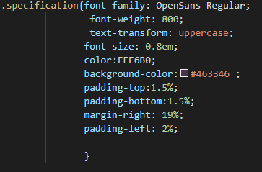



**4.2.1.3 Zanichelli, school edition**

The last cover I reproduced among the already existing ones is Zanichelli's, the school edition released in 2004. In this case, the cover is very schematic and for this reason easier to reproduce.

The only peculiarity it shows is the horizontal alignment of the section containing the text and the image, which I reproduced using the padding and margins of the two sections.

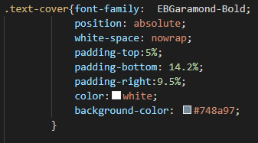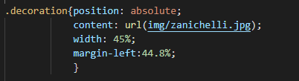

Also in this case, as in the previous ones, in case of reproduction of already existing covers, even if the result is visually appealing or as in this case very good, the doubt remains about the measures and distances adopted in the original versions that are not reproduced perfectly through the CSS library.

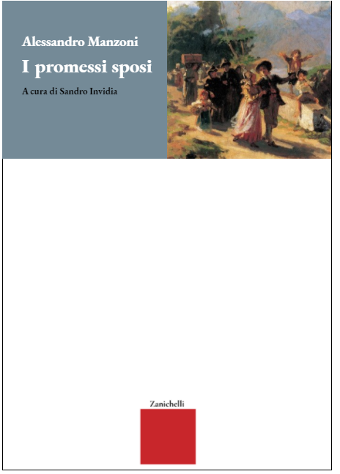

### **4.2.2 Creation of covers following the style of Adelphi, Einaudi and il Mulino**

The second use I made of the CSS library was to create the covers of imaginary editions, always of Promessi sposi, but in this case, based on the style of the three publishing houses analysed in the previous chapters: Adelphi, Einaudi and il Mulino.

Unlike the preceding case where I had a well-defined model to follow, in this case, although I continued to have some limitations dictated by the style of the publishing houses with regard, for example, to the layout of the elements on the page, I had more freedom of choice especially concerning the images, their size and colours.

**4.2.2.1 Adelphi**

For the reproduction of Adelphi's style, I decided to refer to the most iconic graphic design of the publishing house, that of the " Biblioteca Adelphi", which has remained almost unchanged over time.

For the colour of the cover, I chose an antique pink, an elegant and timeless colour. As a reference image of the text I decided to include "The Triumph of Death" by an unknown artist, it is a fresco preserved in the Regional Gallery of Palazzo Abatellis in Palermo, the choice fell on this one to resume the theme of the plague and the suffering that it accompanies the settings described by Manzoni.

This cover was the most complex to create due to the presence of the three frames around the elements of the cover. To avoid to create an image that would act as a cover with the help of another graphics program without being sure that it would align perfectly with where I wanted to place the elements, I decided to use only the files I had available. For their creation, I used the frames of the elements already present in the HTML page as the author, the editor and the logo of the publishing house.

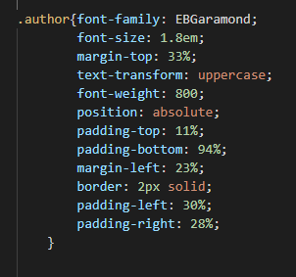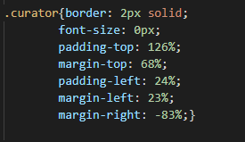4

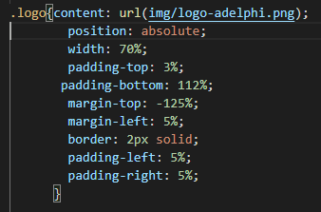

Compared to an original text in the "Adelphi Library" series, I decided not to include the number corresponding to the text that Adelphi places next to the name of the publishing house, I also decided not to transform the title font into italic in order to maintain greater uniformity with the author's name.



**4.2.2.2 Einaudi**

For Einaudi I decided to take as a reference the series The "Millenni" famous for hosting classic texts that want to be proposed to current literature, in particular, I referred to the graphic design of 1984. Einaudi already has an edition of the "Promessi sposi" in pocket format released in 2015, but I thought it would be interesting to create a more prestigious edition for such an important text.

As in the 1984 version, I have maintained a linear style: on the white cover, there is only the image, inside a red frame, the title and the logo of the publishing house. As a representative image, I decided to insert an illustration by Francesco Gonin: the illustrator chosen by Manzoni to illustrate his text. In this case, since the cover is white, I decided to add a black border to give more prominence to the space occupied by the cover and in a way that it does not disperse into the white page.

As in the original graphic design, the logo is placed inside a red rectangle that in this case, I made using the borders of the logo itself.

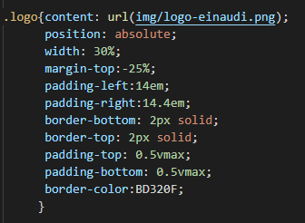

Compared to the original graphics I decided to give more space to the image and reduce the width of the frame to make the cover more delicate, for the same reason I didn't follow the size of the text on the cover, but I decided to use a smaller body.



**4.2.2.3 il Mulino**

For the graphics of the Mulino, since I was dedicated to the analysis of the publishing house's non-fiction text, I decided to be inspired by the latest graphic choices made for that series.

Differently from the original series, I did not insert the word "Saggi" next to the logo of the publishing house because it would not have coincided with the type of text I was referring to.

Also in this case for the cover image, I used the illustration by Francesco Gonin as an example but in this case, through Gimp I inserted it inside a male profile that metaphorically should represent Manzoni's face. A characteristic that I wanted to maintain is the size of the image in the centre of the cover which is the text of il Mulino is large and occupies a large part of the cover.

For the choice of the colour of the box containing the author's name and title, I chose a colour according to my preferences, making sure that it could fit into the range of colours used by the publishing house. For the font, unlike the original, I set a smaller body for the text to give more prominence to the image.



### **4.2.3 Creation of a new cover for "I promessi sposi"**

The last use I made of the library is the one that allowed me to create a completely new cover of l Promessi sposi. I tried to use a simpler and contemporary graphic design style compared to those currently on the market.

For the realization of the covers of a hypothetical edition I chose to include the illustrations of the two protagonists: Renzo and Lucia, made by Francesco Gonin who, under the writer's instructions, produced in detail the drawings of the characters of the novel.

During the design phase of the covers I decided to focus only on the front cover and not on the plug or the back as it is the only one that is visible on digital platforms. Furthermore, I thought it was necessary to take into account the fact that the cover should also capture attention in black and white, which is how it is displayed on eReader devices.

I chose to leave the cover white, surrounded by a frame so that the figures would stand out and not make the cover overloaded with too many colours. As for the title instead, it is in the middle, between the two illustrations to emphasize in a symbolic way the connection between them and be immediately visible. To give a more juvenile look to the text I have added a coloured doodle underneath the title to give the idea of a text read and " experienced" by a student because it is a type of scribble that could be done on a text.

At the bottom right I also inserted a fictional logo to suggest where I would have inserted the name of the publishing house: clearly exposed but which is only visible secondarily.

In this particular case, where I had no constraints in having to follow the style of other publishing houses, the use of the library was even simpler and more linear, as can be seen from the code lines.

In addition to the media queries in the CSS file with the properties that must remain unchanged also in this file I referred to some media-queries but only in relation to the devices where I wanted certain elements to appear in a specific position or of a particular size such as the name of the author or the logo of the publishing house.

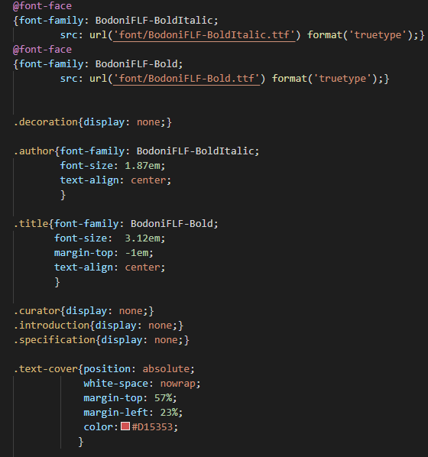

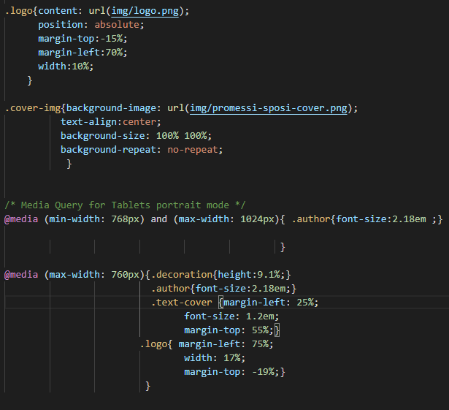

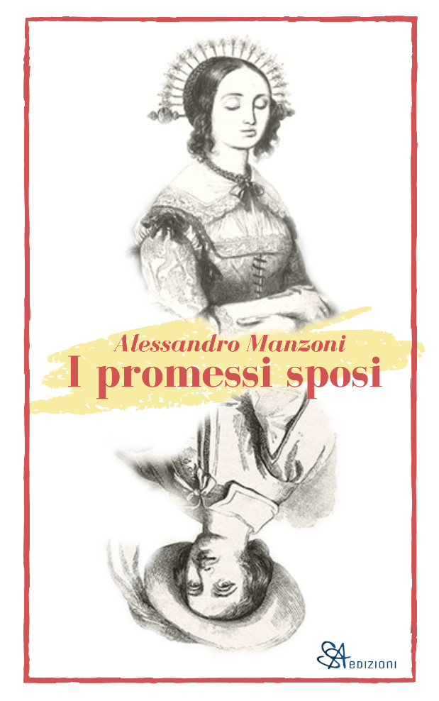

## **4.3 General evaluation of the library: pros and cons**

This library allows everyone familiar with the CSS and HTML language to reach the goal I initially set: to create quickly and easily, following very different styles, book covers adapted to different devices.

The library allows reducing the time spent for the creation of the covers since it gives the possibility to avoid all the technical and basic issues concerning the dimensions and the devices to be considered. These are properties that have already been specified in the fixed-properties-CSS. Furthermore, once the HTML file with the information related to a specific text has been modified and the fixed-properties-CSS is linked to it, the designer will automatically have a responsive cover page and can only be focused on the customization of the designer-CSS file that allows him/her to create the covers according to the desired style.

Therefore, designers using the files in the library, do not have to start from scratch every time they decide to create a cover, but they can use the basic information that remains the same for each type of cover and this allows them to save time and devote more attention to the creative part. In my opinion, this is one of the strong points in using the library.

Another interesting aspect of using this library is that it allows a publishing house to maintain consistency and uniformity between the covers of the same series. It is possible to use the same style sheets or properties previously created, without having to begin from scratch every time to create something similar to what was done previously. Besides, using the library makes it possible to fix homogeneous classes and a standard working method that facilitates and speeds up the work of a team that is faced with more organised codes that share the same structure.

Below an example of how changing a limited number of properties in the designer-CSS file allows the creation of book covers that could be part of the same series. In particular, I took as reference the publishing house Il Mulino and I recreated a hypothetical edition of Dante's Divina Commedia to show the limited number of values that I modified from the files dedicated to the promessi sposi to create it.



To create the cover of the Divina Commedia, a total of seven values were modified in the CSS file for the designer and two in the HTML file. Having the three complete files available and having to make only these changes, the time required to make them was extremely short.

Below is the modified CSS file with the indication of the changed values and the reference to how it was previously for the cover of I promessi sposi.

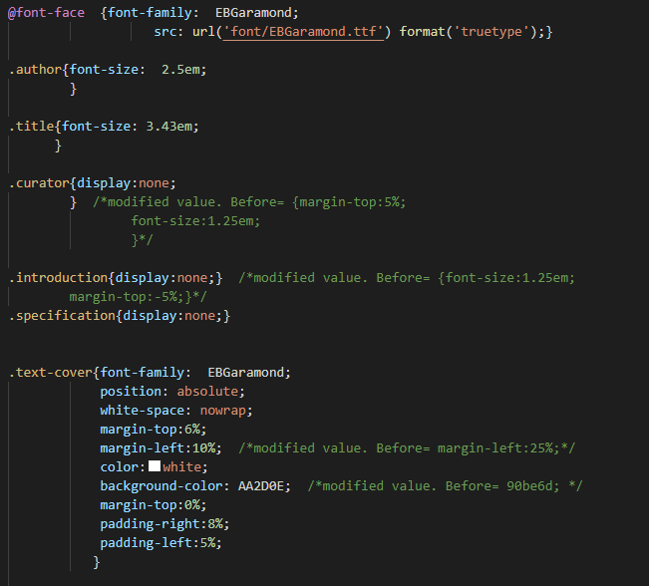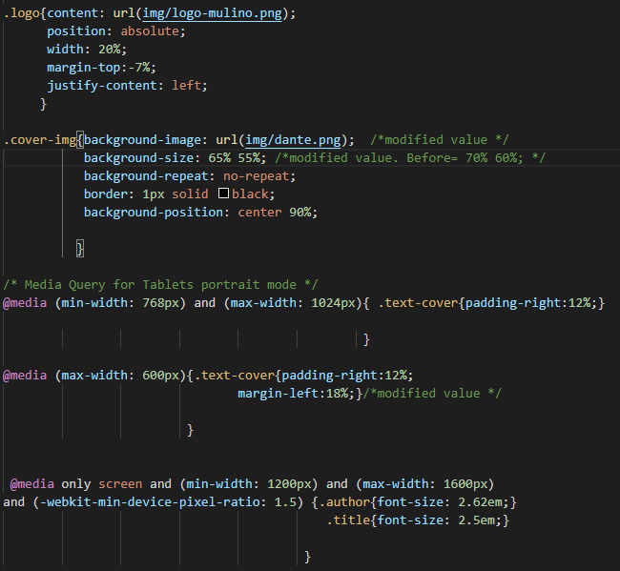

In the HTML file, however, the changes in my case only concerned the title and the author, but I could also have modified the information about the curator, the introduction and specification quickly and easily if I needed them.

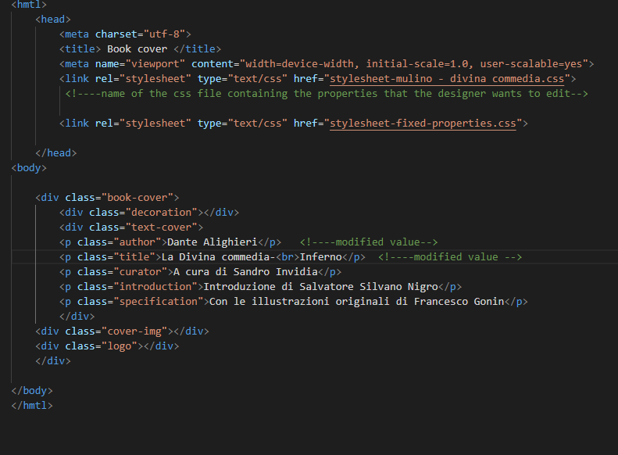

Using a CSS library has some disadvantages including the fact that it limits in some ways the designer in the creation of the covers. Differently from other graphics programs where there is more freedom, with the use of the library the designer can save time but is in a certain way is stuck with the same framework. For example, using the HTML file present in the library, he/she is limited on the number of contents that can include. An example of this has been found during the creation of the cover on the Adelphi style, where for the realization of the iconic frames of the covers I had to use le properties of the elements present in the file which otherwise I would not have needed.

One problem that could generally be found in the use of CSS library is the presence of useless classes for some designers who do not need to use them. In the particular case of the library that I created, since it is made specifically to facilitate the creation of book covers, the classes that it presents, in most cases, are common to all texts, so those that the designer may not use are very limited in number, specifically, they could be the following:

- Curator

- Introduction

- Specification

As it was possible to notice during the realization of the covers, in some cases I didn't need to use these classes and in these contexts, I fixed them using the property "display: none;" which allowed not to show this element.

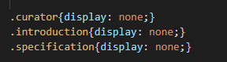

The positive side, however, is that being a basic library with limited code and easy to interpret classes, the designer can quickly modify it according to his or her needs without wasting hours understanding the classes and style of the undesired element.

Another risk in which many designers are afraid to encounter using a CSS library is the waste of time required to understand how it works since they are not yet familiar with the library itself and its classes. In this specific case, I think that this issue does not concern the library I created, since it is minimal and narrow, and in the website dedicated to the library I have tried to explain how it works through the use of examples that make clear the way it can be used.

Indeed, according to the table below, there are only ten classes in the HTML file. Two of them, the most challenging, are already modified for the creation of covers in the CSS file defined "fixed properties" that the designer does not have to modify, the others can be customized in the file dedicated to him/her that allows him/her to quickly modify properties, for example concerning fonts, colours, images of the various classes.

|  |  |  |
| --- | --- | --- |
| Classes | Classes treated in the CSS fixed-properties file | Classes treated in the CSS designer file |
| Book-cover |  |  |
| Decoration |  |  |
| Text-cover |  |  |
| Author |  |  |
| Title |  |  |
| Curator |  |  |
| Introduction |  |  |
| Specification |  |  |
| Cover-img |  |  |
| Logo |  |  |

After using the library, I noticed an additional advantage in using it, I believe that those who know, even basic, of the HTML and CSS language, might find it easier to use than other graphics programs, for which it would take more time to learn its functionalities. This positive aspect can be seen, for example, in the covers I created by reproducing the ones on the market, whose result is very similar to the original (Feltrinelli, Mondadori and Zanichelli), the graphics of which were probably created using more elaborate programs.

Using the library to reproduce already existing covers, I found two problems that caused non-substantial differences between the covers I created and the originals: firstly, not having the images or decorations in high quality because they were downloaded from the internet, however, I believe that this problem can be easily solved by the publishing houses that have them available. The second problem found, in this phase, is the lack of information about the precise measurements, for example about the position of the elements inside the page, the size of the images that only the graphics of the publishing house know. In this case as well, when a publishing house decides to use this library to reproduce its covers, it will be able to retrieve them and make perfect reproductions.

During the creation of covers with more detailed graphics or elements, like Feltrinelli's or Mondadori's, for example, I evaluated that it is not possible to use only the library but it is necessary to use other programs that facilitate the creation of further elements like the decorations on the covers. I do not consider this aspect the negative side of the library because it allows keeping the files linear as possible and does not complicate their use: simplifies the work of the graphic designers who can attach the decorations directly in the CSS file.

A feature that I found especially in the use of the library for the creation of covers inspired by well-known publishing houses (Adelphi, Einaudi and il Mulino), is the possibility to add adjustments to the original graphic design to adapt it perfectly to the visualization of covers on various devices, even with smaller screens. Using the library, it is possible to verify the final rendering of the covers on different devices and then evaluate which modifications should be made for better visualization. This feature could facilitate the work of designers and help them to produce covers that currently it is fundamental that they are visible even in small formats.

In conclusion, after several uses of the library both for the reproduction of already existing graphics and for the creation of new covers, I think it can be a functional tool that gives the possibility to produce good results. It allows designers who are familiar with the HTML and CSS language, but also those who are beginners, given the simplicity of the classes and properties that can be exploited, to create every kind of cover, from the most classic to the most creative and in step with the times

# **Conclusion**

Today advertising is a part of our everyday life, which can be seen from the analysis made in the first chapter. It is all around us. From the last century also book covers can be classified as a kind of packaging that advertises the product and in this sense, it is not very different from a traditional advertising campaign.

Just like advertising posters, the cover of a book has very similar functions: create a sense of curiosity, make the customer want to try the product, encourage to buy a new product, represent a brand, in this case, the publishing houses.

The cover is the first thing that readers will see when browsing for a book, and how it looks both as a thumbnail and in full size is crucial to the success of the publication.

Each cover has to compete with the others on the bookshelf, attracting the possible buyer's attention before informing them about the contents of the text (Dabne, Calvert, Anoki 2011, 58).

The covers, in particular, are a challenging design product created to capture the attention and suggest something of the story that lies between the pages. It also allows the customers to orient themselves in front of a physical or digital showcase and to distinguish the different literary genres.

After having made a historical analysis of the evolution of advertising to understand which aspects were subsequently incorporated into the world of publishing graphics, I focused more closely on the history of covers, which made it possible to look at the book from the point of view of the graphic designer, the person who produces it, and communicates it to the outside world: a different vision from the one usually taken when referring to the world of publishing.

In the sixteenth century, the frontpage was created: the first page of a book in which parts of the information about the text are presented. Even in this case, its evolution was rapid: if at the beginning it contained only the title, from the seventeenth century onwards it was enriched with decorative elements, which remained in vogue little more than a century until the advent of neoclassical taste that eliminated the superfluous aesthetic and highlighted the essential information on the text. On the cover, meanwhile, the name of the author was occasionally indicated on the back, but nothing else. We have to wait until the middle of the nineteenth century, to encounter the cover with its current form and function: to make each book recognizable concerning another, to attract the attention of the potential buyer, to give him the necessary information to orient him or not towards the purchase (Ollister 2018).

Following the historical and general analysis of the covers, I focused more attention on the evolution of the graphic design of three Italian publishing houses: Einaudi, Adelphi and il Mulino, to examine how they have managed to build their own identity maintaining linear covers, and to underline the differences between the graphics of narrative texts and non-fiction: comparing the covers of Einaudi and Adelphi with those of il Mulino. At this stage, it was observed that the visual impact of the covers of narrative texts was more elegant, less geometrical and more representative of the content contained in the text than that of the non-fiction, despite the presence of the same elements for the composition of the covers: author, title, image, name and logo of the publishing house.

Moreover, the reflections made on Einaudi and Adelphi have allowed focusing attention also on the theme of the series. The cover is the protagonist of the desire to create a continuous visual line within the publishing houses that crosses series, historical moments and different cultural influences. The series, with its name, already places a strong emphasis on the structure: a book belonging to a series always recalls the other books published in the same, and with them inevitably forms a coherent dialogue. The series is recognizable for the homogeneous graphic layout of the products that refer to it. (D'Ambrosio 2008, 142).

It emerged that if the volume is part of a series, the decorative apparatus, the font, the layout used will be inserted in the graphics of the rest of the series, to make it clear that the book is part of a delineated editorial path. Referring again to the world of advertising: if the cover is compared to the packaging of a product, the publishing house, for some scholars, can be considered as a brand. A strong brand, with a recognizable identity that imposes its own identity on the products on which it is applied. As in the cases analysed by Einaudi and Adelphi, for example, they are two powerful brands, capable of giving past and a precise identity to their goods with just their name. Einaudi is an example of the desire to visually express a corporate identity through its graphic design, to make a book identifiable and unique, first for its image and then for its contents. The Einaudi novels, even if very different and with a precise series identity, are nevertheless united by the same brand identity that makes them distinct from the texts of other publishing houses. It is clear that the Einaudi brand name is a response to precise strategic intentions and is addressed especially to those who may have a particular reception of that brand: the community of Einaudi readers, traditionally far from the circuit of newsstands and hyper-economic editions (D'Ambrosio 2008, 145).

The Adelphi case is different again, with its declared policy of "libri unici" and coloured covers deliberately created to move away from white Einaudi. In this case, the graphic uniformity that presides over all the Adelphi series gives rise to a strong connotation that reflects from the House to all the titles published by it (D'Ambrosio 2008, 146).

The research carried out has made it possible to go further than the traditional analysis and study of books, which usually focuses on content. It has allowed reflecting on the complexity of this sector in a historical and cultural context in which the role of the cover is increasingly important for communicating and promoting the book, partly because of the increase in both sales channels and tools where it is possible to read. The birth of books in digital format and the entry of new technologies has caused great changes in the world of publishing graphics, where designers have had to experiment more and revolutionize the way they design covers, which now have to be attractive in very small formats and often in black and white. In this context, publishing houses have taken the opportunity to create original visual lines that are at the same time consistent with their paper aesthetics and renew their appearance to adapt to a digital system that goes beyond the bookstore and reaches websites, socials and tablets.

Despite these changes, designing a cover continues to involve translating a verbal message into visual, creating a business card that allows the reader to get a first impression of what he/she is going to read.

My thesis was intended to offer an overview of the importance of covers, in particular of today's world of editorial graphics of some Italian publishing houses, with an emphasis on the evolution of their graphic design.

Moreover, I wanted to understand the role of graphic design in the publishing world and find a solution that could speed up the process of making covers. Currently, it is important to make them in different formats and this led me to the creation of a CSS library, which through the use of three files: one HTML file containing the text that must appear on the cover and two CSS files, one that must remain unchanged with information on the size of the cover that allows to display them on smartphones, tablets, e-readers and traditional books, and the second file that the designer can modify to create the cover with the desired characteristics. They allow to quickly modify and adapt the cover to the desired format. After having tested the library in three different ways: reproducing existing covers, creating new ones inspired by Italian publishers and finally creating a completely new cover, I have concluded that having the library and good knowledge of the CSS language can achieve good results in a short time.

The analysis carried out has revealed a world that is experimenting to evolve towards a future where the editorial design will adopt new visual languages and closer proximity to the parallel virtual world.

**Bibliography**

Agostino, Filippo, Orsi, Federica, Verardo, Nadia, Corsi, Simona, Costa, Sergio et al. 2014. *Storie in copertina: protagonisti e progetti della grafica editoriale: con bozzetti e illustrazioni / presentazione di Ambrogio Borsani*. Pavia: Santa Caterina.

Ambrose, Gavin. 2009. *Il libro del layout: storia, principi, applicazioni*. Bologna: Zanichelli, 2009.

Ambrosio, Gabriella. 2005. *Le nuove terre della pubblicità.* Roma: Maltemi.

Amlesu, Arnaldo*.* 1993. *Grafica editoriale: guida alla progettazione e produzione di depliant, brochure, riviste.* Milano: Ikon, 1993.

Anaya, Michelle A. 2008. Changing appearances: magazine advertising layout and design, 1980-2005. San Jose State University. Master's theses and graduate research.

Baroni, Daniele. 2003. *Maurizio Vitta, Storia del design grafico.* Milano: Longanesi.

Budani, Kathrine and Timoteo, Laura Timoteo. 2016. *Adelphi – Editoria dall’altra parte.* Roma: Oblique studio.

Calasso, Roberto. 2013. *I libri unici* da [*L’impronta dell’editore*](https://www.adelphi.it/libro/9788845927744). Milano: Adelphi. [<https://www.adelphi.it/la-casa-editrice>]

Codeluppi, Vanni. 2001. *Che cos'è la pubblicità*. Roma: Carocci editore.

Codeluppi, Vanni*.* 2012. *Ipermondo. Dieci chiavi per capire il presente*. Roma: Bari Laterza, 2012.

Codeluppi, Vanni*.* 2013. *Storia della pubblicità italiana*. Roma: Carrocci editore.

Colonetti, Aldo. 1989. *Disegnare il libro: grafica editoriale in Italia dal 1945 ad oggi*. Bologna: Grafis.

Dabner, David, Calvert, Sheena, Anoki, Casey. 2011. *Graphic design: principi di progettazione e applicazioni per la stampa*, *l'animazione e il web*. Milano: Hoepli.

De Fusco, Renato. 2002. *Storia del design. Nuova.* ed. riv. e ampliata, Roma: GLF editori Laterza.

[Drew, Ned](https://www.giuntialpunto.it/search?bnid=411663031&asort=Relevance&bt=Autore%3A%20Drew%2C%20Ned&adv=author%3DDrew%2C%20Ned) and [Sternberger, Paul](https://www.giuntialpunto.it/search?bnid=411663031&asort=Relevance&bt=Autore%3A%20Sternberger%2C%20Paul&adv=author%3DSternberger%2C%20Paul)*.* 2005. *By Its Cover: Modern American Book Cover Design*. New York: [Princeton Architectural Pr](https://www.giuntialpunto.it/search?bnid=411663031&asort=Relevance&bt=Editore%3A%20Princeton%20Architectural%20Pr&adv=brand%3DPrinceton%20Architectural%20Pr).

Falcinelli, Riccardo. 2011. *Fare i libri: dieci anni di grafica in casa editrice*. Roma: Minimum fax.

Ferretti, Gian Carlo, Iannuzzi, Giulia. 2014. *Storie di uomini e libri: l'editoria letteraria italiana attraverso le sue collane*. Roma: Minimum fax

Ferretti, Gian Carlo. 2004. *Storia dell'editoria letteraria in Italia, 1945-2003*. Torino: Einaudi.

Gallagher, Daniel Patrick. 2015. *The Look of Fiction: A Visual Analysis of the Front Covers of the New York Times Fiction Bestsellers*. Thesis. Rochester Institute of Technolgy. Accessed from

https://scholarworks.rit.edu/theses/8919.

Istituto Alvar Aalto di Torino. 2004. *L'arte del Novecento e il libro*, Catalogo della Mostra di Torino, Milano: Lybra immagine.

Landa, Robin. 2010. *Advertising by Design, generating and designing creative ideas across media.* Second edition. New Jersey: John Wiley & Sons, Inc.

Richards, Jef, Daugherty, Terry and Logan, Kelty. 2009. “Advertising history”. In *Encyclopedia of Journalism*, edited by Sterling, Christopher H. New York: Sage Publications [<https://www.researchgate.net/publication/272494431_Advertising_History>].

Starch, Daniel. 1914. *Advertising. It’s priciples, practice and technique*. New York: Scott, Foeesman and company.

Terenzi, Benedetta. 2012. “Gli antefatti della comunicazione grafica in Identità e immagine”.In *Identità e immagine.* 21-35. Bergamo: Edizioni Valle Imagna. [<https://www.researchgate.net/publication/328173072_Gli_antefatti_della_comunicazione_grafica>].

Tschichold, Jan*. 2003. La forma del libro,* introduzione di Bringhurst Robert. Ed. a cura di Passerini Lucio. Milano: Sylvestre Bonnard.

Tungate, Mark. 2007. *AD a global history of advertising*. United Kingdom: Kogan, 2007.

Vignelli, Massimo. 2011. *Il canone Vignelli*. Milano: Postmedia Srl.

**Articles**

Acquarelli, Luca, Cogo, Michele and Tancini Francesca. 2013.“Il peritesto visivo copertine e altre strategie di presentazione”. Serie speciale della rivista on-line dell’Associazione Italiana di Studi Semiotici, Anno VII, n. 13.

Belpoliti, Marco. November 28, 2018. “Luciano Foà e la nascita dell’Adelphi”. Doppiozero. (28/08/2020). [<https://www.doppiozero.com/materiali/luciano-foa-e-la-nascita-delladelphi>]

Bricchi, Mariarosa. May 13, 2013. “Adelphi, o l’editore ineffabile”. Le parole e le cose. (28/08/2020). [<http://www.leparoleelecose.it/?p=10232>]

Carton, [Anne. May 12, 2018.](https://www.designhill.com/design-blog/author/annecarton/) “The Evolution of Book Cover Design”. Designhill. (28/08/2020). [<https://www.designhill.com/design-blog/evolution-of-book-cover-design/>].

Colombo, Valentina. January 8, 2013. “(Non) giudicare un editore dalla copertina” Topipittori. (28/08/2020). [<http://topipittori.blogspot.com/2013/01/non-giudicare-un-editore-dalla-copertina.html>]

D’Ambrosio, Mariano. 2008. “Editoria e pubblicità: le copertine”. Allegoria n.57, Anno XX. Terza serie, gennaio/giugno 2008, [https://www.allegoriaonline.it/index.php/i-numeri-precedenti/allegoria-n57/24-il-presente/5755/108-editoria-e-pubblicita-le-copertine]

Ferrero, Ernesto. July 8, 2019. “Einaudi, lo stile in copertina”.La Stampa. (28/08/2020).

[<https://www.lastampa.it/cultura/2016/04/03/news/einaudi-lo-stile-in-copertina-1.36588514>]

Gallegos, Jose Angelo. June 24, 2020. “The History and Evolution of Advertising”. TINT. (28/08/2020). [<https://www.tintup.com/blog/history-evolution-advertising-marketing/>]

Guillermou, Tiphaine. August 31, 2017. “A short history of book covers –4/4”. Grapheine. (28/08/2020). [<https://www.grapheine.com/en/history-of-graphic-design/history-of-book-covers-4>].

Guillermou, Tiphaine. July 12, 2017. “A short history of book covers –3/4”. Grapheine. (28/08/2020). [<https://www.grapheine.com/en/history-of-graphic-design/history-of-book-covers-3>].

Guillermou, Tiphaine. June 14, 2017. “A short history of book covers – 1/4”. Grapheine. (28/08/2020). [<https://www.grapheine.com/en/history-of-graphic-design/history-of-book-covers-1>].

Guillermou, Tiphaine. June 29, 2017. “A short history of book covers –2/4”. Grapheine. (28/08/2020). [<https://www.grapheine.com/en/history-of-graphic-design/history-of-book-covers-2>].

[Jacklyn](https://medium.com/@Jacklyn_Lee?source=post_page-----6f7f85670313----------------------). May 14, 2019. “The History of Book Covers”*.* Medium. (28/08/2020). [<https://medium.com/@Jacklyn_Lee/the-history-of-book-covers-6f7f85670313>].

Lant, Karla. 2017. “Anatomy of a book cover”. 99designs. (28/08/2020). [<https://99designs.it/blog/book-design/anatomy-of-a-book-cover/>].

Montenegro, [Daymette. October 2017.](https://www.researchgate.net/profile/Daymette_Montenegro?_sg%5B0%5D=TYtX3Dk0ABwyh-rQuhSHvaEFD-ab8mDn4YzwHIFdlmmpuYdwMsXRT3R6LpUGrzdSz5vz6kA.hPA9bPEb57eJRFJobDV5JXJ21hj6borawFaMJJK4BD-Ij7Fke0OMWVgEFGn8NiMp1oOHgflpJFdozuTZQOeJqQ&_sg%5B1%5D=evlAD8y4JxICBfsUSlUewchB-6GalnAsGmn0pzXC67Of4vxEEedVIEVkWhuuhxmcDKXIBVQ.PtG0FnFuFpZVqNxuxLUWexgcoGiBGnzvWc38ZSZ-x5ZnZ3l2RXfSd46Z_c6jym1PveDutRYr0OJ0eJjtHNbQsA) “The history of advertising”. Researchgate. [<https://www.researchgate.net/publication/320719721_THE_HISTORY_OF_ADVERTISING>]

Mujtaba, Sammiya. May 13, 2014. “Advertising Layout”. [Review](https://sammiyamujtaba.wordpress.com/category/review/). (28/08/2020). [<https://sammiyamujtaba.wordpress.com/2014/05/13/advertising-layout/>].

Nicoletta. February 19, 2020. “*Case editrici italiane: Adelphi”.* Il Blog Di Mano in Mano. (28/08/2020). [<http://notizie.dimanoinmano.it/2020/02/19/case-editrici-italiane-adelphi/>]

Novin, Guity. 2016. “Chapter 55; Design for Book Cover and Dust Jackets”. In A history of graphic design. The online text book. (29/08/2020). [ <http://guity-novin.blogspot.com/2012/03/chapter-55-book-cover-and-book-jacket.html>]

Ollister, Petunia. August 3, 2018. “Le copertine dei libri”. Hoppipolla. (28/08/2020). [<https://hoppipolla.it/blog/copertine-dei-libri/>].

Ornella. May 19, 2019. “I colori dell’editoria: l’arcobaleno Adelphi”. Sotto la copertina. (28/08/2020). [<https://sottolacopertina.home.blog/2019/05/19/arcobalenoadelphi/>]

Ornella. May 2, 2019. “I colori dell’editoria: Bianco Einaudi”.Sotto la copertina. (28/08/2020). [<https://sottolacopertina.home.blog/2019/05/02/libriedintorni-i-colori-delleditoria-bianco-einaudi-%f0%9f%93%9a/>]

Papi, Giacomo. June 9, 2016. “Le copertine dei libri diventano un’altra cosa?”. Il post. (28/08/2020).

[<https://www.ilpost.it/2016/06/09/internet-cambia-copertine-libri/>].

Passera, Claudio. November 17, 2014. “Cover design: quel che raccontano le copertine dei libri”. Nuovo utile. (28/08/2020). [<https://nuovoeutile.it/copertine-dei-libri/>].

Piazza, Mario. March 29, 2016. “*Il libro al centro: l'Einaudi e la grafica”.* Doppiozero. (28/08/2020). [<https://www.doppiozero.com/materiali/il-libro-al-centro-leinaudi-e-la-grafica>]

Reed, Danielle. August 16, 2017. “History of Online Advertising”. Study.com. (28/08/2020) [study.com/academy/lesson/history-of-online-advertising.html].

Saporito, Cristiana. June 4, 2020. “Adelphi: l’editoria come genere letterario”. Flaneri. (28/08/2020). [<http://www.flaneri.com/versione-stampa/?articolo=3588>]

Sas, Britt. June 22, 2011. *“*The cover, a cultural object”. The icon workshop. (28/08/2020). [<http://histoirevisuelle.fr/cv/icones/1818>]

Snyman, Magdaleen. May, 2015. “The History of the Book Jacket in the 19th and Early 20th Century”. *The Journal of Publishing Culture* Vol. 4.

Vitalba Giudice, M. “Adelphi: sinonimo di letteratura colta e di qualità per un’editoria intesa come espressione artistica”. Direfarescrivere” Anno XI, n. 110, February 2015 [<http://www.bottegaeditoriale.it/Uneditorealmese.asp?id=157>]

**Sitography**

Adelphi <https://www.adelphi.it/>

Einaudi <https://www.einaudi.it/>

Il mulino <https://www.mulino.it/gruppo/sviluppo>

1. Images of the covers, where not indicated, were taken directly from the catalogues of Einaudi, Adelphi and il Mulino
2. [https://www.einaudi.it/la-casa- editrice/#:~:text=Anni%20Trenta,del%20liceo%20classico%20D'Azeglio.&text=Se%20nel%20gruppo%20dei%20fondatori,direttore%20editoriale%20della%20casa%20editrice.](https://www.einaudi.it/la-casa-%20editrice/#:~:text=Anni%20Trenta,del%20liceo%20classico%20D'Azeglio.&text=Se%20nel%20gruppo%20dei%20fondatori,direttore%20editoriale%20della%20casa%20editrice.)
3. <https://www.mulino.it/gruppo/sviluppo>